MODEL
SEN 1100
CONVEYOR OVEN
(DIGITAL SCREEN)
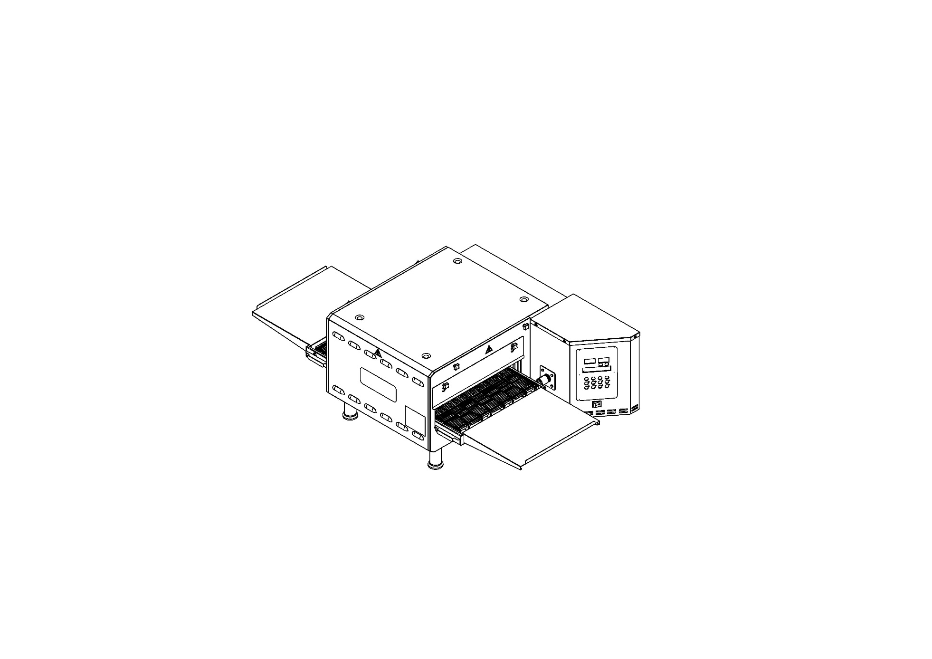

USER & MAINTENANCE MANUAL

ŞENGÜN MAKİNA İNŞAAT ve KIRTASİYE SAN. TİC. LTD. ŞTİ

These instructions apply only if the country code is shown on the device. If the country code does not appear on the device, refer to the technical instructions that give instructions for adapting the device to the country.

This device must be installed in accordance with regulations. Refer to the instructions before installing and using the device.

These instructions apply only if the country code is shown on the device. If the country code does not appear on the device, refer to the technical instructions that give instructions for adapting the device to the country.

This device must be installed in accordance with regulations. Refer to the instructions before installing and using the device.


WARRANTY CERTIFICATE
SERIAL NUMBER :
SALE DATE :
Sold at the above date SEN 1100 MODEL MICROPROCESSOR CONTROL BLOWING OVEN is guaranteed against production failures for 1 Year by ŞENGÜN MAKİNA İNŞAAT ve KIRTASİYE SAN. TİC. LTD. ŞTİ.

Warranty Terms;
- Warranty terms start after the product delivery for 1 year.
- Recommended daily working time is 10 hours. The scope of warranty is assessed by year or by working hours.
- Documents are invalid, if haven’t sale date and confirm signature of company. You have to show the warranty certificate to benefit from the warranty.
- Device is guaranteed against defects if mount and use as described in the use and maintenance manual.
- Detection the location of defects, and elimination of the problems are responsibilities of the ŞENGÜN MAKİNA…
- Warranty terms includes only one device. You can’t claim any rights or compensation for another devices.
- If Changes are made at the type, model and serial numbers, the warranty eliminates.
- If material, worker or assembly defects appear, repaired free by ŞENGÜN MAKİNA at the product warranty period (Transportation cost is not included).
- Failures are only repaired by ŞENGÜN MAKİNA’s personal. The intervention of unauthorized person, cancel the appliance of warranty.
- Installation have to be done by ŞENGÜN MAKİNA’s personal. İf usage place changes, customer must give information to ŞENGÜN MAKİNA
- In the event of failure service must be informed.
- The failures and damages given by external factors are out of the warranty terms.
- Any failure of the product warranty period is added to the product warranty time. The repair time is until 20 working days.
AUTHORIZED PERSON
STAMP –SIGNATURE

PRESENTATION

Dear Users,
Thank you for your prefer our machine and confidence in our company. Our machines are used in 39 countries.
Our machine is manufactured according to international standards. Please read the operating manual to get the mast out of your machine. Please note the following warnings before calling our service.

ŞENGÜN MAKİNA

- Please read the manual carefully before installing the machine.
- The machine will be out of warranty when your operate the machine with at read.
- Please read carefully the manual that gives you information on the installation is prepared in accordance with the legal regulations before arriving at the machine installation.
- For information you coonot understand, ask your nearest out horized service
- Please note that if the technical service personnel is kept waiting you will be billed for each hour.

IMPORTANT WARNINGS AND SAFETY INFORMATION:
 WARNING: This manual contains important safety and installation-operation instructions. Require all operators to read this manual thoroughly before installing, operating or servicing this equipment. Improper installation, adjustment, alteration, service or maintenance can cause property damage, injury or death.
WARNING: This appliance is not intended for use by young children or infirm persons unless they have been adequately supervised by a responsible person to ensure that they can use the appliance safely. Young children should be supervised to ensure that they do not play with the appliance.
WARNING: Improper installation, adjustment, alteration, service or maintenance can cause property damage, injury or death. Read the installation, operating and maintenance instructions thoroughly before installing or servicing this equipment.
WARNING! Do not work around conveyor belt with long hair, loose clothing, or dangling jewelry. Getting caught in the belt could result in serious injury.
WARNING! For your safety, do not store or use gasoline or other flammable vapors or liquids in the vicinity of this or any other appliance.
 WARNING! If the power supply cord damaged, do not attempt to operate the unit. Contact a service agent or qualified electrician to repair!
WARNING! Do not use paper when placing food product through the oven! Usage of flammable materials may cause a fire and should never be placed in the oven.
WARNING! Do not put any object to anywhere of the oven except the conveyor.
WARNING! Always be careful while you are working.

- The oven must be placed under a ventilator to provide for adequate air supply.

- Minimum clearances must be provided from all walls and combustible materials. Look “spacing requirements” section for more information.

- Always keep the oven clean and clear combustible materials.

- Keep adequate clearance for air openings.

- Do not obstruct the ventilation holes.

- The oven is to be operated only on as shown on the specification plate.

- This manual should be retained for future reference.

- Prepare a list of what you should do when you smell gas and keep it near the oven.
- Gas does not pass through the burner without electricity.

Responsibilities of the Purchaser Company
Responsibilities of the purchaser company are written at bottom;
- To see that the electric and gas services for the oven are installed in accordance with the manufacturers specification.
- İnstalling the oven and placing it as suggested at the catalogue.
- To see that the electric services are connected properly by a qualified installer of your choice.

WARNING

Cleaning and maintenance are the most important factors of oven performance. The processes which are not available in the manual can cancel the appliance of warranty, cause property damage, injury or death. Read and understand the instructions in the manual

WARNING

Cleaning and maintenance are the most important factors of oven performance. The processes which are not available in the manual can cancel the appliance of warranty, cause property damage, injury or death. Read and understand the instructions in the manual

CONTENTS
WARRANTY CERTIFICATE

RESENTATION

SECTION 1: INTRODUCTION
1.1 Introduction of Body Components
1.2 Functions of Parts
1.2.1 Oven Body
1.3 Overlap Assembly
1.4 Microprocessor Control
1.5 Cooking Function
1.6 Conveyor (Belt)
1.7 General Information
1.8 Oven Specifications
1.9 Electrical and Technical Specifications Table
1.10 Dimensions

SECTION 2: ASSEMBLE
2.1 Product Out Sheet
2.2 Front/Back Waste Collecting Sheet
2.3 Entry and Exit Cover Sheet
2.4 Stopper Sheet (Optional)
2.5 Belt Assembly
2.6 Belt Wire Assembly
2.7 Legs Assembly
2.8 Low Chassis Assembly
2.9 Double Floor Oven Assembly:
2.10 Air Duct Disassembly / Assembly

SECTION 3: INSTRUCTIONS FOR USE
3.1 Distance Requirements
3.2 General Information of Ventilation
3.3 Ventilation Advice
3.4 Installation Elements
3.5 SEN 1100 Oven Technical Specifications Table

SECTION 4: PROGRAMMING-START & STOP
4.1 Operating
4.2 Warnings
4.3 Closing
4.4 Function
4.4.1 Temperature Cutting Switch
4.4.2 Band Right Left Function
4.4.3 Electrical Installation
4.4.4 Operator Maintenance
4.4.5 Cleaning Instructions
4.4.6 Preventive Maintenance
4.4.7 Contact with Technical Services:

SECTION 5: COOKED PRODUCTS
5.1 Some of The Cooked Products
5.2 Cooking Time and Temperature
5.3 Total Cooking Calculation

SECTION 6: SPARE PARTS MANUAL

SECTION 7: ELECTRICAL DIAGRAM
SECTION: 8 TROUBLESHOOTING
8.1 Products Do Not Cooked
8.2 Contact With Technical Services

SECTION 9: LABELS

NOTES

ECTION 1: INTRODUCTION

1.1 Introduction of Body Components:
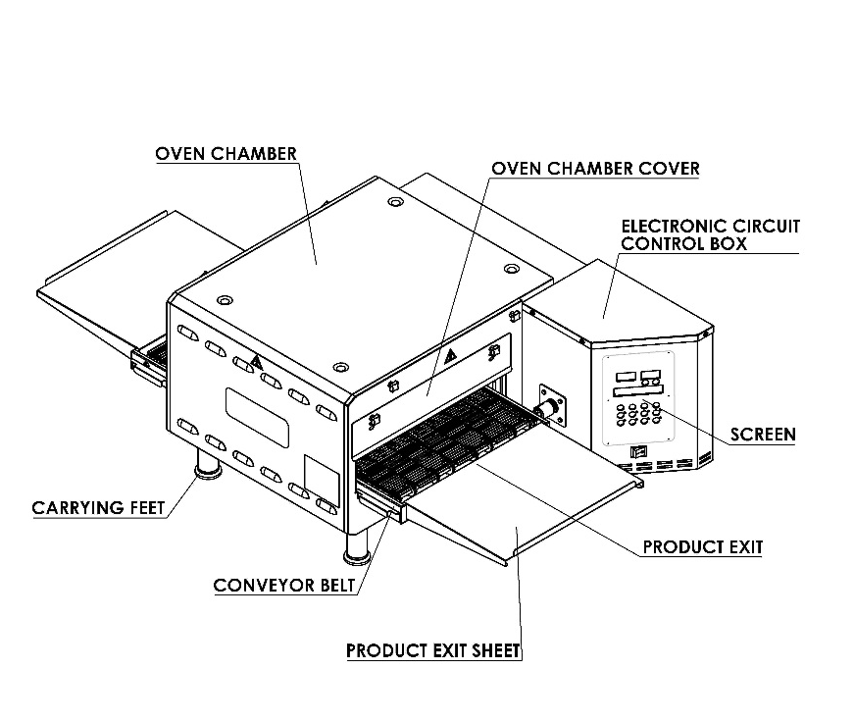

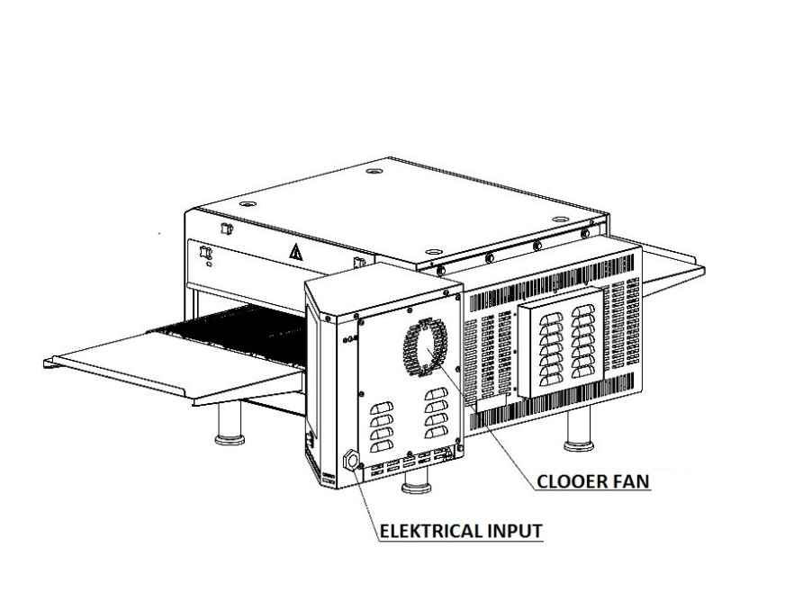

NOTE: Entrance of product depends for the cooking style. The out sheet can be attached other side of the oven.
1.2 Functions of Parts:
1.2.1 Oven Body:
Every SEN series oven has a main body.

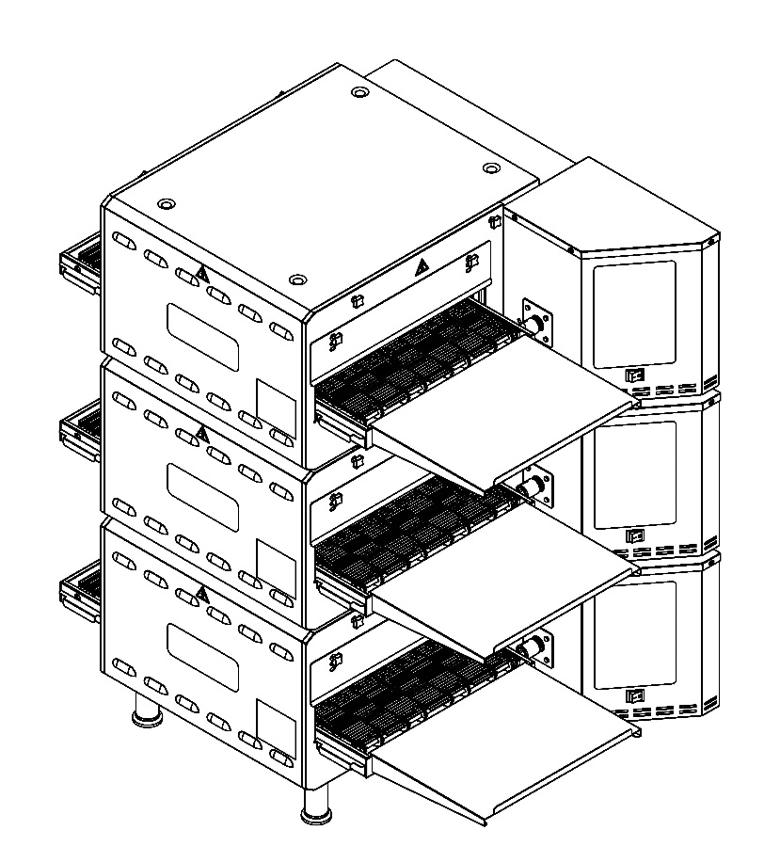
1.3 Overlap Assembly:
ŞENGÜN MAKİNA series ovens can be used to overlap two or three. The ovens assembled to the chassis and connect each other.

Note: When you put ovens one on the top of the other there is stabilizing holes for stabilize ovens.

1.4 Microprocessor Control:
Every single oven is controlled by separate programmable microprocessor. The microprocessor controls all functions of the oven. Oven temperature can be set between 90°C to 300°C. And the cooking time can be set between 1 - 30 minutes. You can cook standard and delicious products in a short time.
1.5 Cooking Function:
The oven cooks the products standard and delicious by circulating compressed air.
AIR DUCT
CONVEYOR BELT
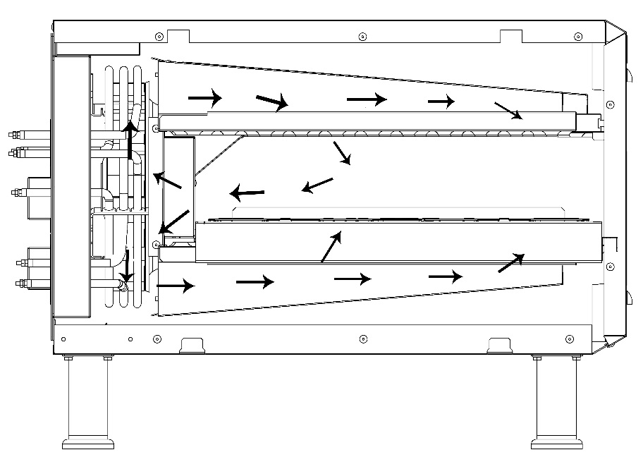

AIR DUCT

1.6 Conveyor (Belt):
Conveyors provide the input and output of the product. Belt is controlled by microprocessor. Cooking time can be set between 1 - 30 minutes. The speed of belt determines the Products cooking time. The width of belt is 406 mm and consist by interlocking wires.

1.7 General Information:
- Information which are located at the following pages will guide you at installation of the oven.
- First of all check the parts of oven carefully.
- Before the installation determine a safety place for oven.

1.8 Oven Specifications:
 | SEN 1100
Conveyor Belt Width : | 406 mm
Heating Chamber Length : | 530 mm
Heating Chamber Size : | L 530 mm X W 437 mm x H 124mm
Conveyor Cooking Area : | 0,23 m²
Main Dimensions – One Oven With Counterfort : | Oven Width: 773 mm  Oven Height: 458 mm  Total Long: 1370 mm
Main Dimensions – Two Oven Overlapping (Counterfort) : | L 1080 x W 760 x H 815
Main Dimensions – Three Oven Overlapping (Counterfort) | L 1080 x W 760 x H 1516
Main Dimensions – Two Oven Overlapping (Frame) | L 1080 x W 760 x H 1170
Chassis Dimensions of the Single Oven - Weight : | L 577 mm x W 512 mm x H 802 mm – 15,8 kg
Weight : | 78 kg
Transportation Single Oven Weight – Domestic (Machine + Chassis + Packing) : | 110 kg
Transportation Single Oven Weight – Abroad (Machine + Chassis + Packing) : | 119,8
Transportation Size (Domestic) : | L 950 mm x W 900 mm x H 580 mm
Transportation Size (Abroad) : | L 1200 mm x W 900 mm x H 630 mm
Average Usage kW : | 3-4 Kw
Allowable Temperature Range: : | 90 °C – 300 °C
Conveyor Drive System : | 208 - 300 Volt Microprocessor  Conveyor control system
Cooking Time : | 1 min – 30 min Adjustable
Insulation : | 4 Side
Heat Source : | 3 Heat sources
Oven Chamber : | Steel (Galvanized)
Steel Enclosure : | 430 Stainless Steel
DB Level : | < 65 dba
Source : | Electricity

1.9 Electrical and Technical Specifications Table:

Electrical and Technical Specifications Table
Voltage | Faze | N | T (PE) | Cable Minimum Section | kW | Ampere Load
 |  |  |  |  |  | L1 | L2 | L3
400V 50/60HZ | 3 | 1 | 1 | 1,5 mm² | 6 kw | 9 | 9 | 10,5

NOTE: Specifications can be changed by ŞENGÜN MAKİNA. Above Specifications are given for information.

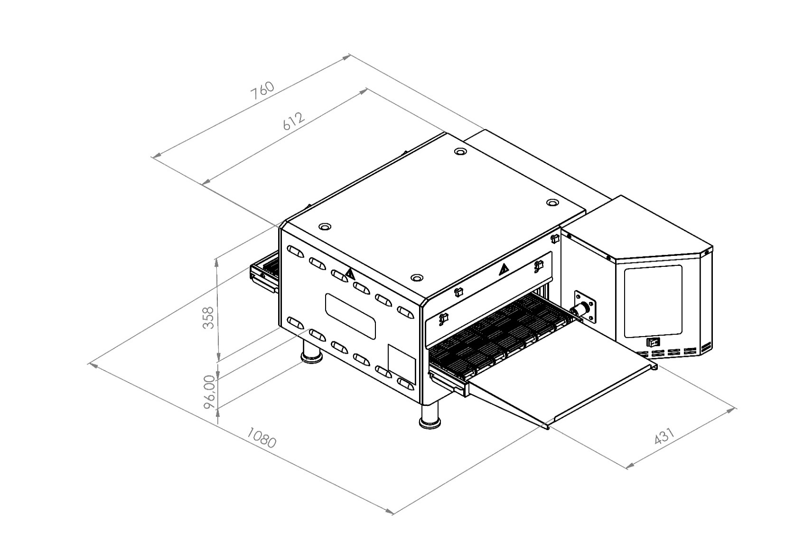
1.10 Dimensions:

Single Oven
(Isometric)

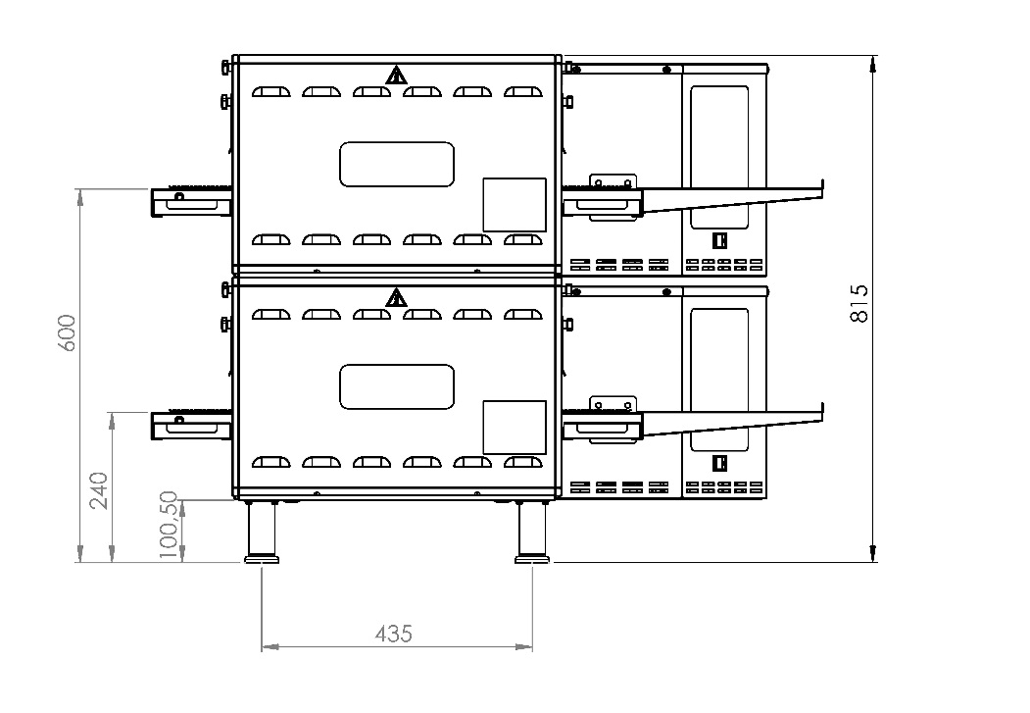
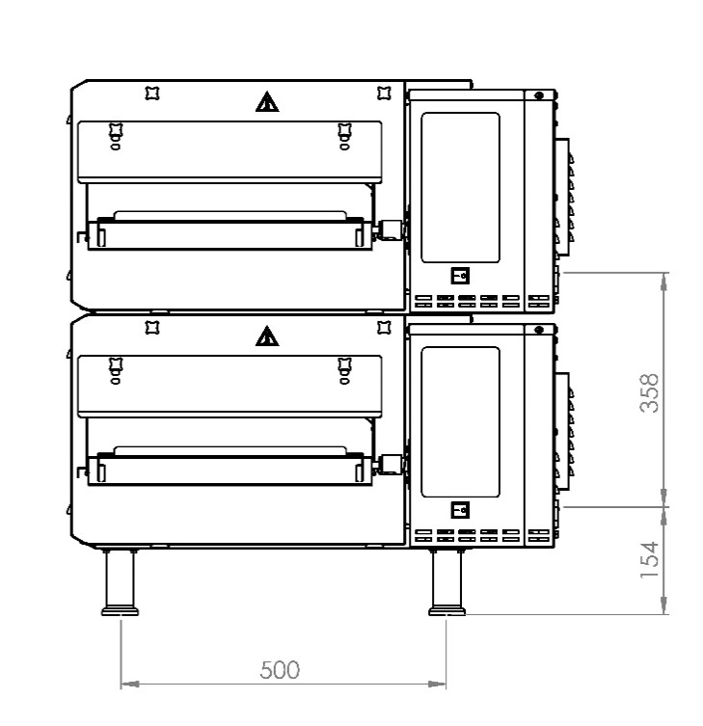
ELECTRICITY ENTRANCE DIMENSIONS

Front View
Duplex
(Side View)

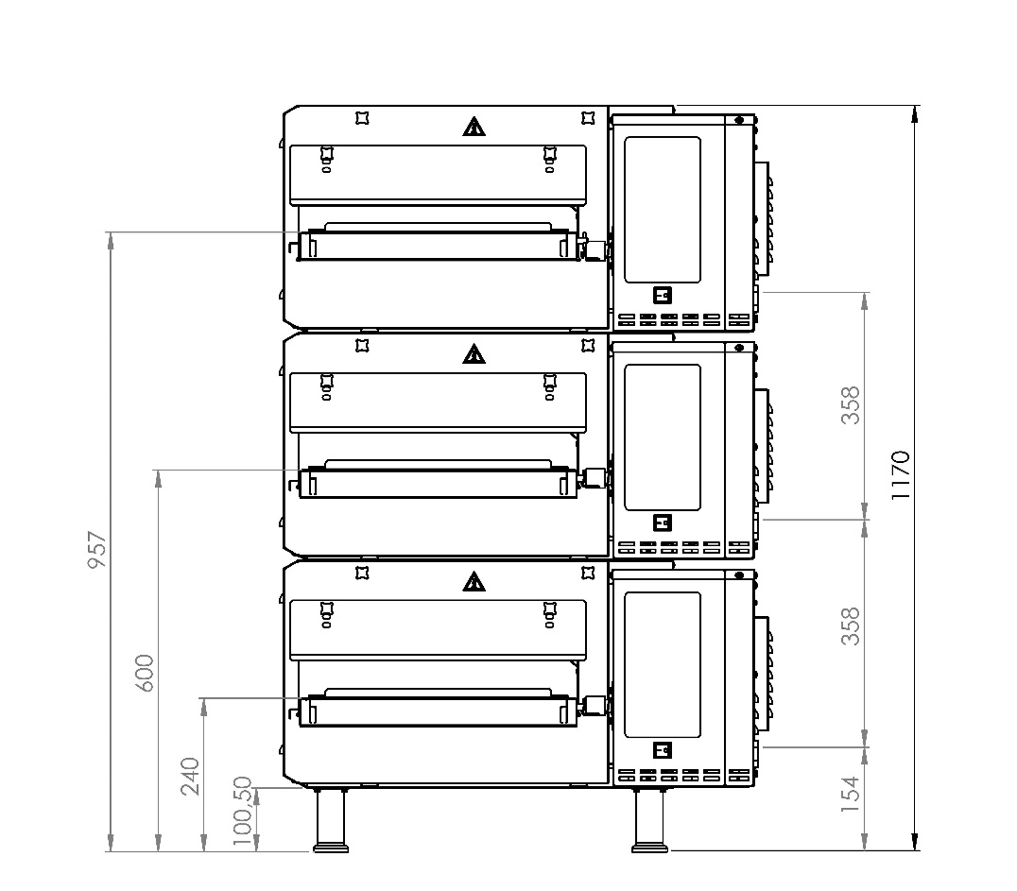
ELECTRICITY ENTRANCE DIMENSIONS

DIMENSIONS OF BELTS HEIGHT

Triplex
(Front View)

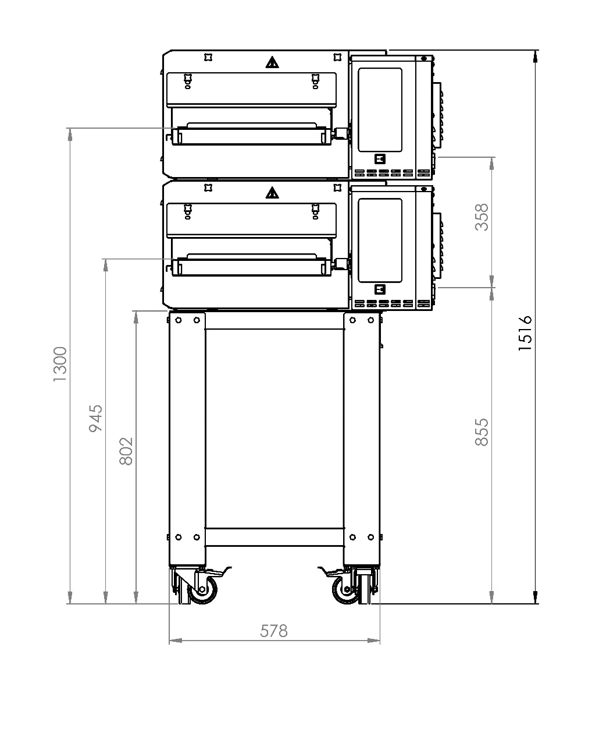

ELECTRICITY ENTRANCE DIMENSIONS

DIMENSIONS OF BELTS HEIGHT

Two Storey
(Front View)

SECTION 2: ASSEMBLE
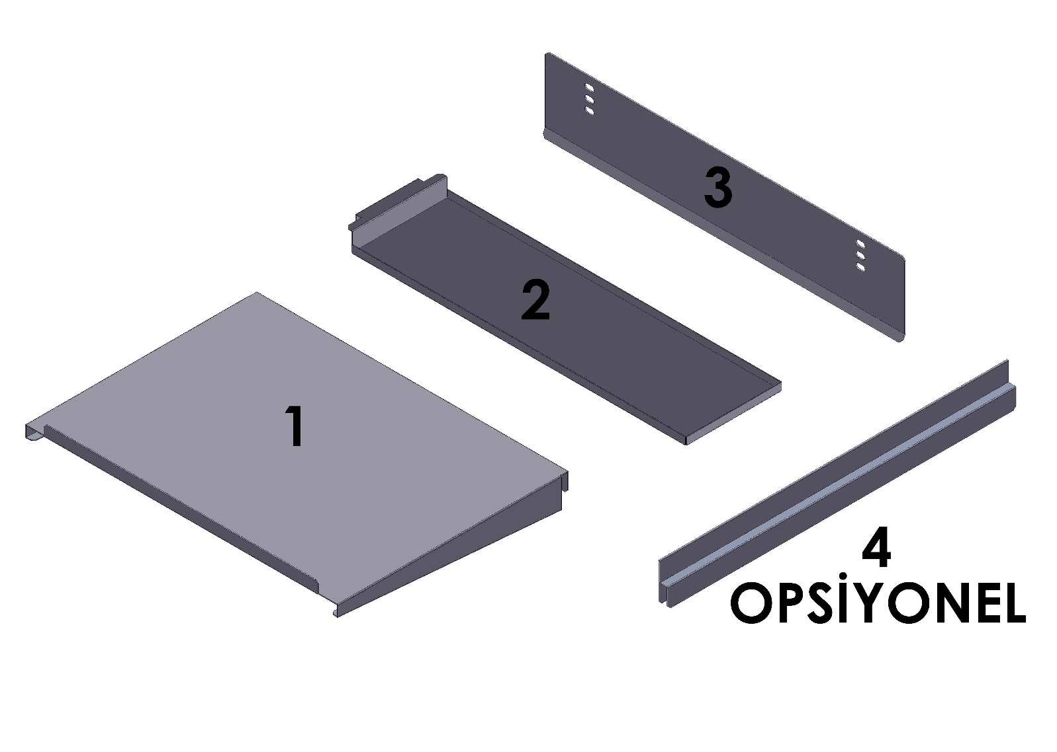
OPTIONAL

NO | PART NAME | UNIT
1 | Product Out Sheet | 2
2 | Forward/Back Waste Collecting Sheet | 2
3 | Oven Room Front Rear Cover | 2
4 | Stopper Sheet (Optional) | 1

2.1 Product Out Sheet:

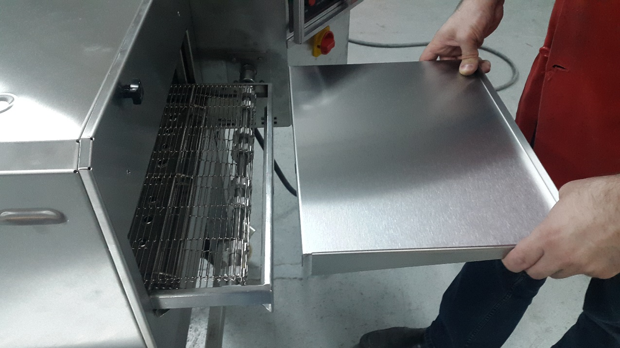
Attach the product out sheet to the conveyor chassis as shown in the figure. And Push it.

2.2 Front/Back Waste Collecting Sheet:

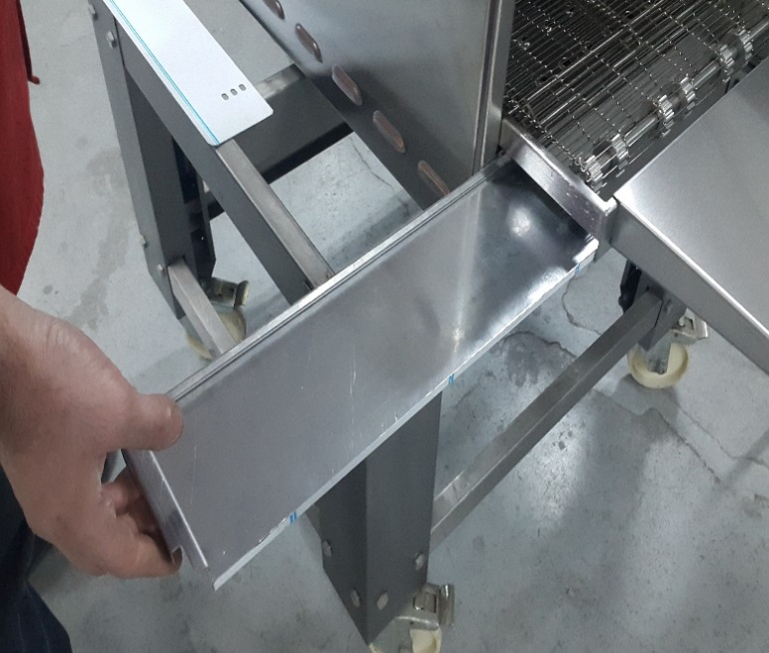
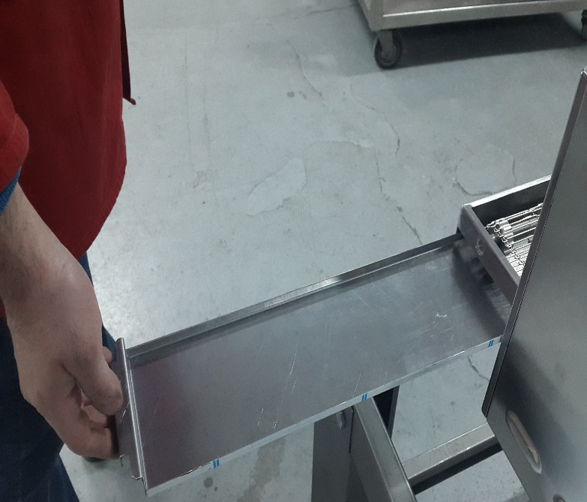

Front and back waste collecting sheets are taken out as shown in pictures.

2.3 Entry and Exit Cover Sheet:
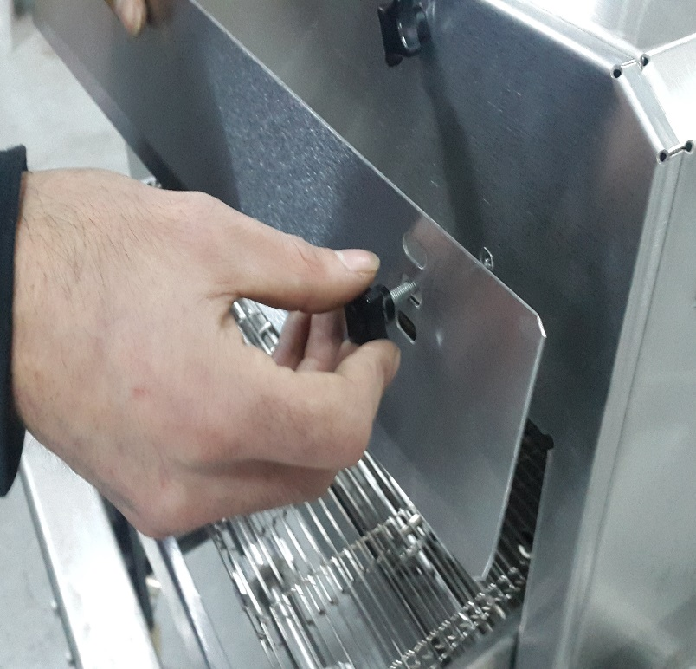
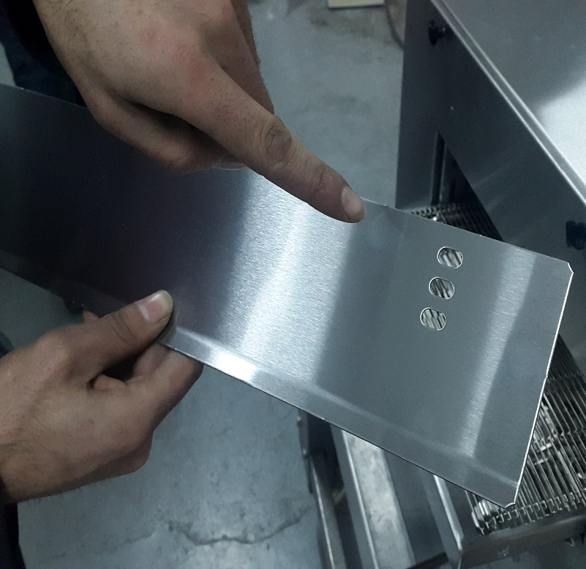

Covers are set as desired through holes which are different levels. Covers are attached by bakelite bolts.

2.4 Stopper Sheet (Optional):
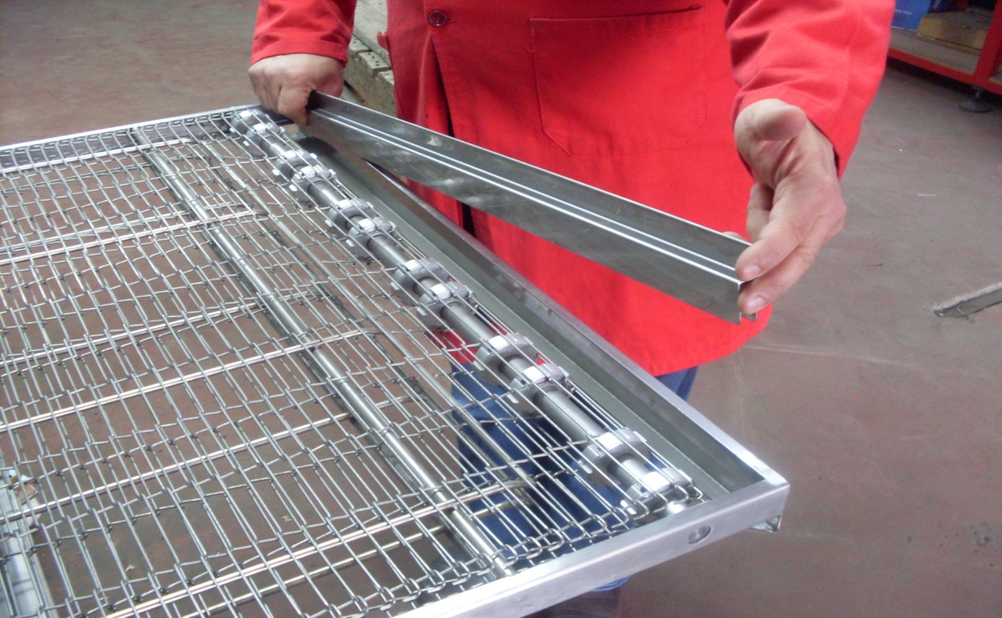

Stopper, blocks the products and keep them into the belt. Stopper is attached to the belt.

2.5 Belt Assembly:
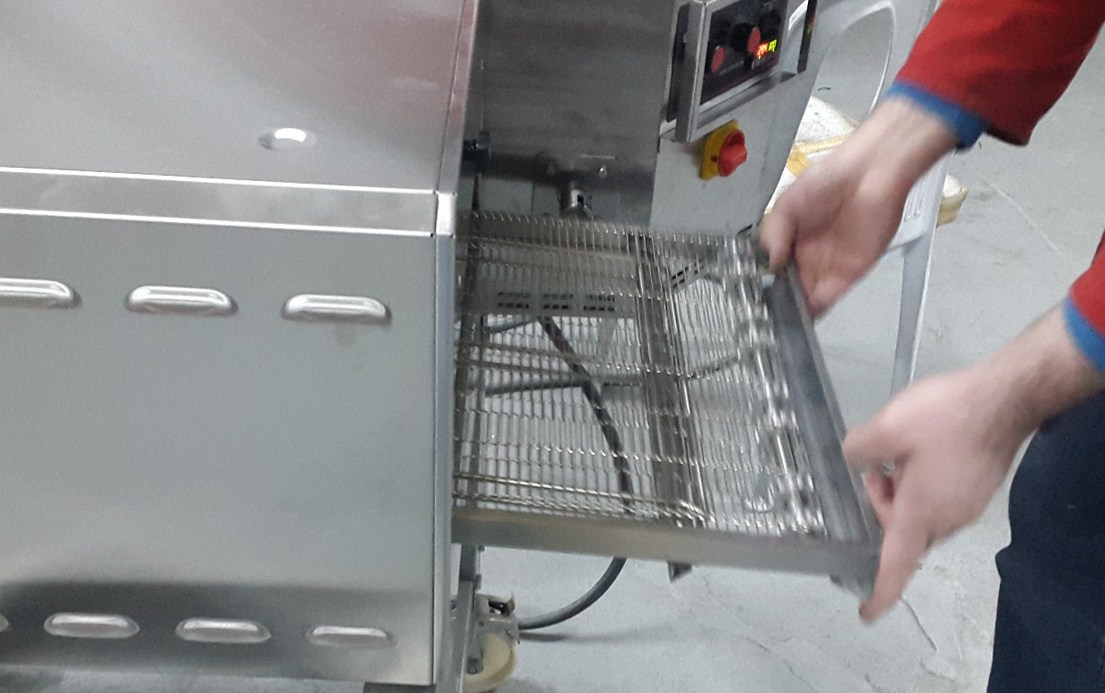

The conveyor is mounted inside the machine as shown in the picture.
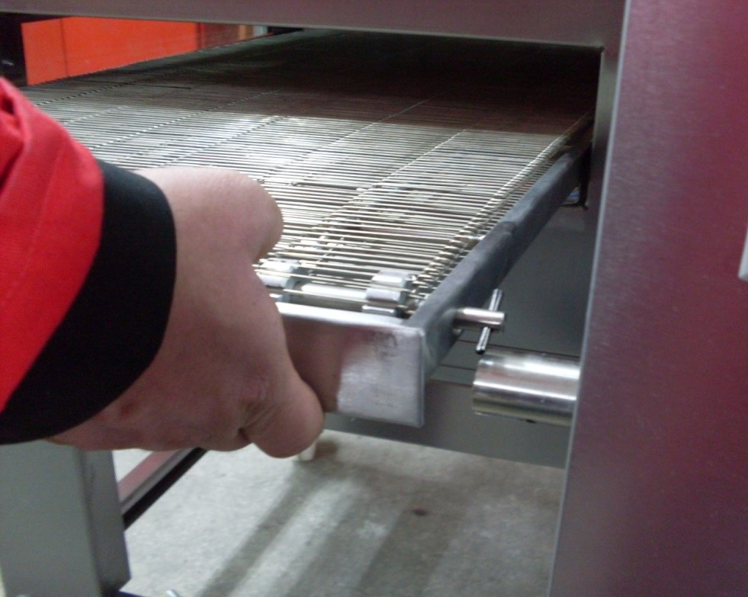

The drive shaft is centered on the clutch pipe.

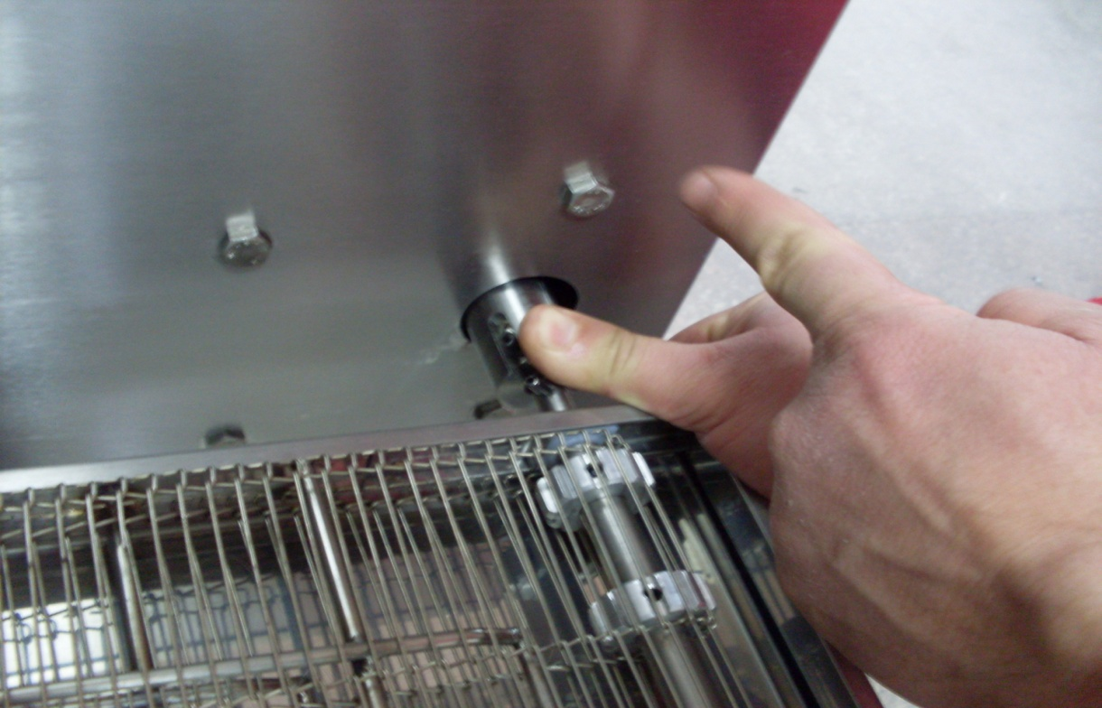

Clutch pipe is attached by the drive shaft spring as shown in the figure.
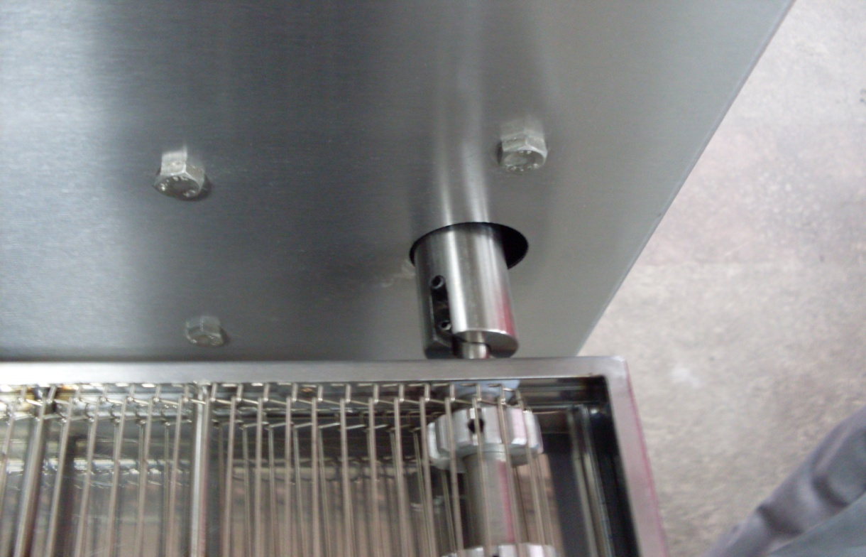

Belt assembly is completed. For disassembly, use every steps in reverse order.

2.6 Belt Wire Assembly:
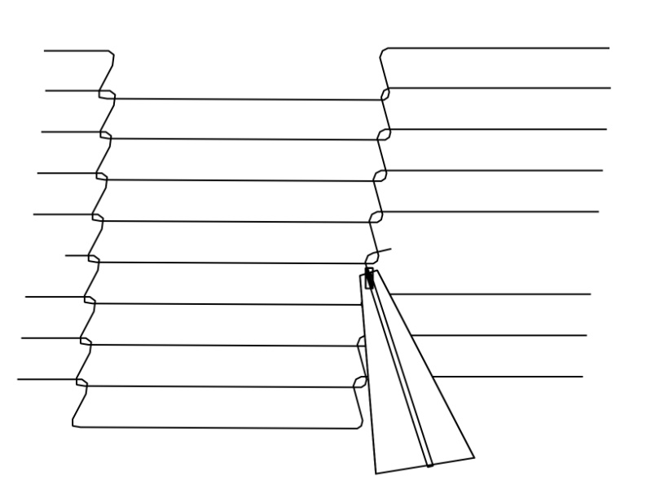
2. Attached by pliers (Middle connecting wire)

1. Installed as shown in the figure. (Edge connecting wire left and right)

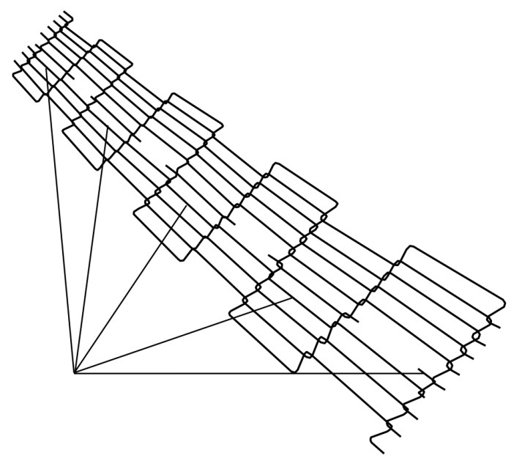

4. The final wire assembly.
3. If belt wire problem appears, remove a wire as shown in the figure.

For disassembly, use every steps in reverse order.

NOTE: Clean the belt wire once a week or month for better performance.

2.7 Legs Assembly:
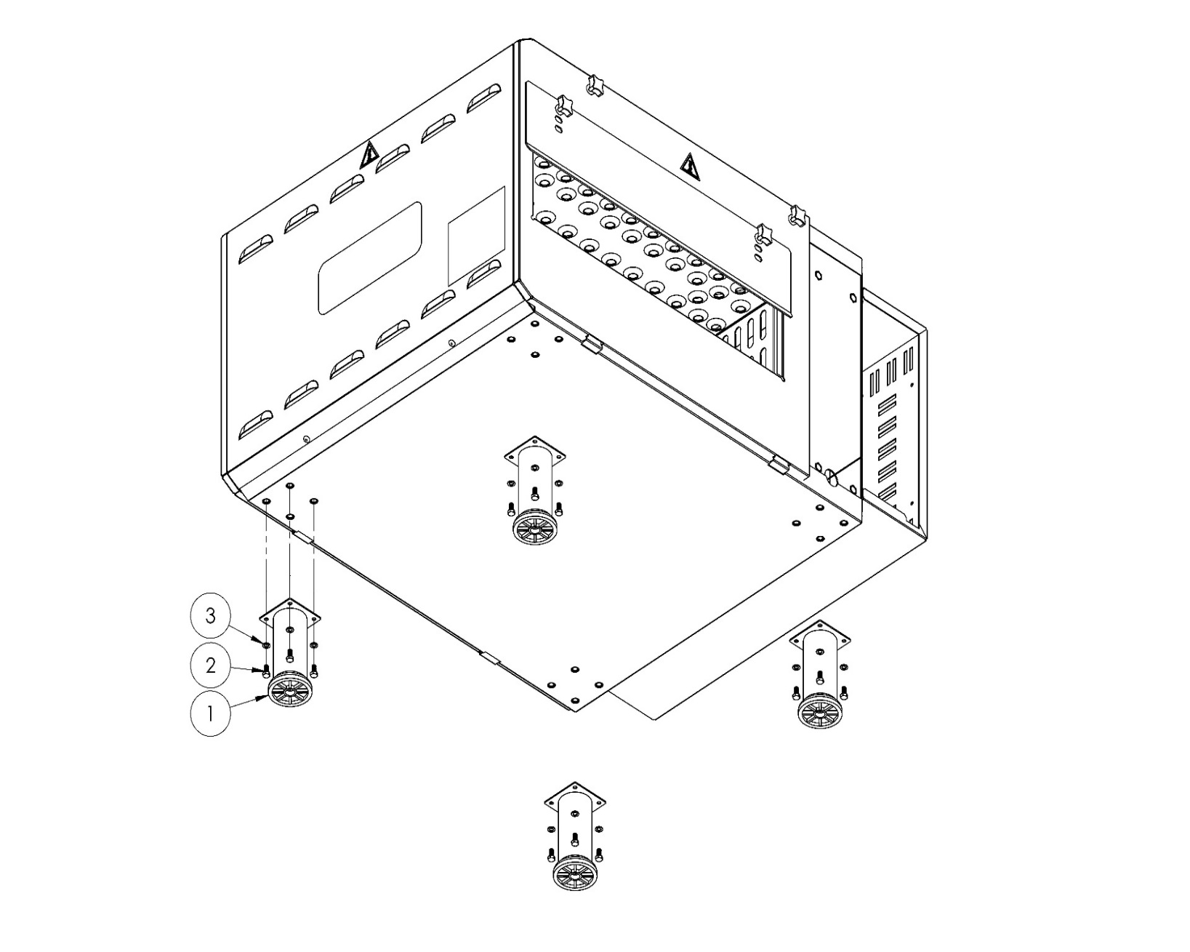

ITEM NO | SPARE PART NUMBER | SPARE PART DESCRIPTION |  | UNIT
1 | 08086 | LEG |  | 4
2 | 01833 | BOLT |  | 16
3 | 01685 | WASHER |  | 16

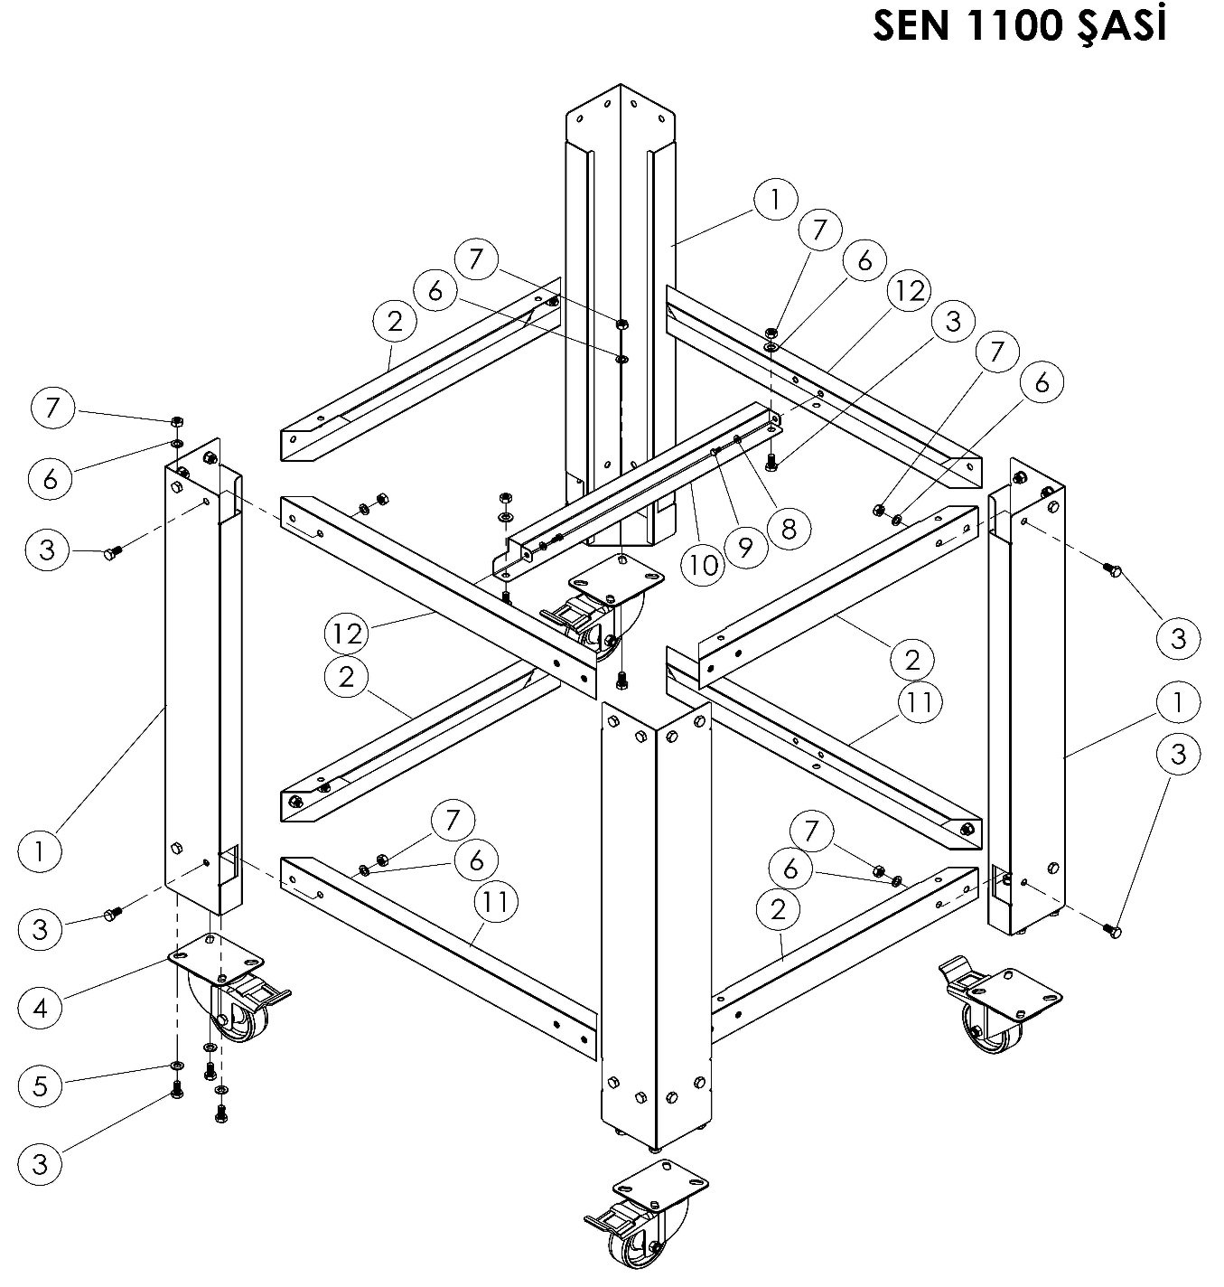
2.8 Low Chassis Assembly:
SEN 1100 CHASSIS

SEN 1100 CHASSIS (L 577 mm x W 512 mm x H 802 mm)
ITEM NO | SPARE PART NUMBER | SPARE PART DESCRIPTION | UNIT
1 | 08153 | LEGS | 4
2 | 02322 | BRACKET SHEET | 4
3 | 01957 | BOLT | 46
4 | 01971 | WHEEL | 4
5 | 01963 | WASHER | 12
6 | 01961 | WASHER | 46
7 | 01959 | NUT | 46
8 | 00051 | WASHER | 2
9 | 00048 | BOLT | 2
10 | 02323 | BRACKET SHEET | 1
11 | 02321 | BRACKET SHEET | 2
12 | 00191M | BRACKET SHEET GROUP | 2

2.9 Double Floor Oven Assembly:
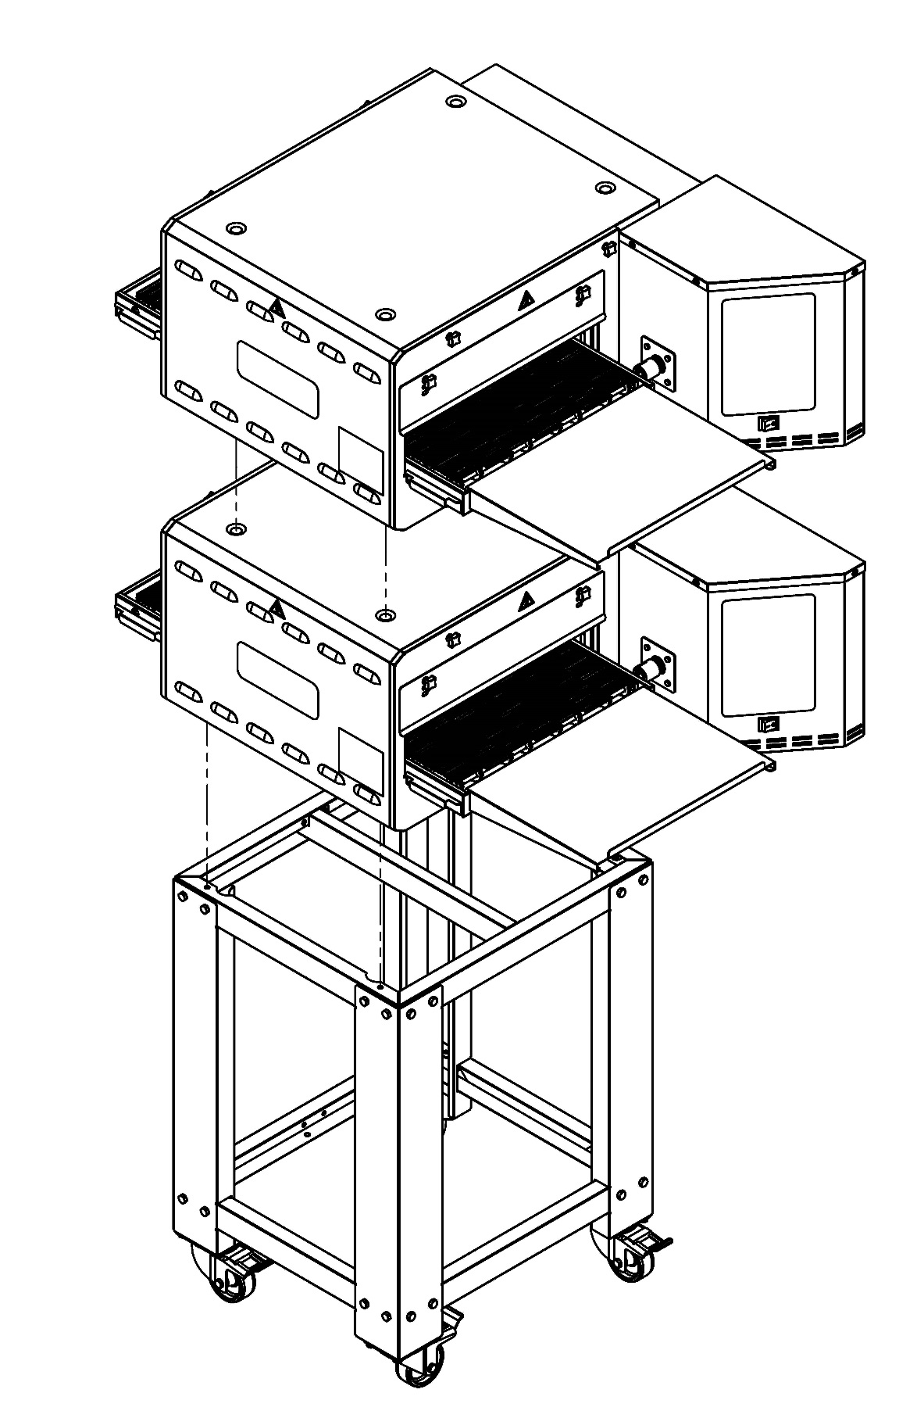

2.10 Air Duct Disassembly / Assembly:
 CAUTION! Oven must to be cold.
- Remove product output plate and product stopper plate (See Pg. 16).
2. Remove conveyor waste collection plates (See Pg. 15).
3. Remove conveyor belt (See Pg. 17-18).
4. Remove cooking room covers (See Pg. 16).
5. Remove air canals as shown figure 1 pull in the direction of arrow.
6. You need to write codes for re-assembly like used to be.
Marking Examples;
Upper air canals: U1, U2
Bottom air canals: B1, B2
7. Remove air canals as shown Fig. 2 and Fig. 3. Apply marking when you remove air canals.
Marking Examples;
Hood U1,
Internal Plate U1,
External Plate U1,
8. You can do cleaning after this process. You can do assembly do reverse what you did.

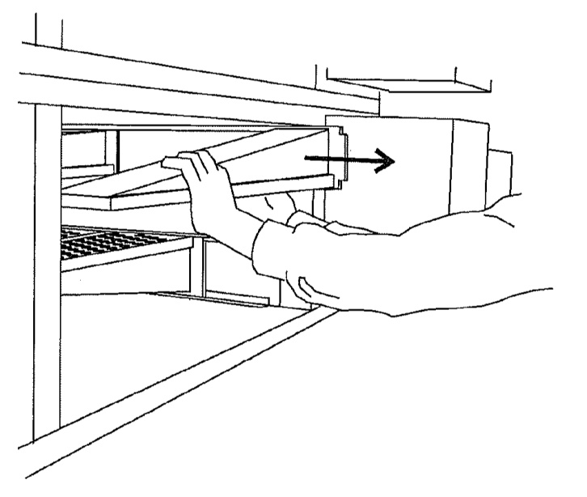

Figure 1

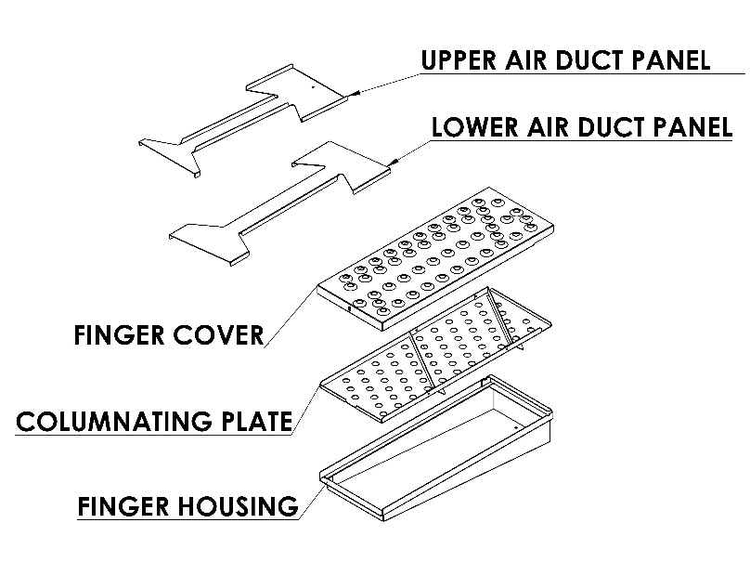

Figure 2

2- Hold flap and pull up.

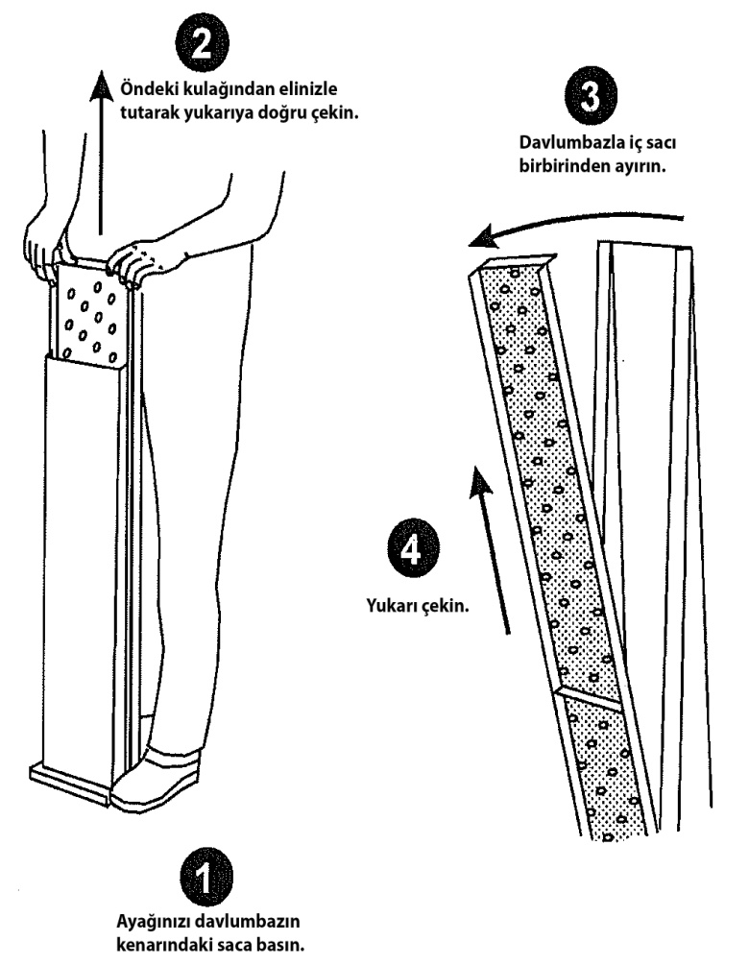
3-Remove hood and internal plate with each other

4
Pull up

Figure 3

1-Press the flap which near hood.

SECTION 3: INSTRUCTIONS FOR USE
3.1 Distance Requirements:
The oven must have 130 mm of clearance from combustible surfaces. In case other equipment is located on the right side of oven, a minimum clearance of 620 mm is required from that equipment.
FOR ALL OVENS: A 620 mm clearance at the rear of the oven must be obtainable for service access.
FOR FIXED OVENS ANY TIME: A permanently installed (unmovable) oven requires a minimum of 340 mm clearance on the right-hand side to allow for conveyor removal, cleaning, and servicing.
NOTE: Do not install this (these) oven(s) in any area with an ambient temperature in excess of 40° C. Doing so will cause damage to the unit.
3.2 General Information of Ventilation:
Ventilation channel or hood should be sufficient to attract heat and cooking odor. In addition, ventilation in gas ovens must be sufficient to expel combustion products. Operation and properly configured ventilation is the responsibility of the furnace owner.
The ventilation mouth (hood) should be in harmony with the general ventilation and heating system.
ANTENTİON: Do not allow air to flow through the cooking tunnel. The air must not be directed to the front top of the oven, to the side or to the rear.

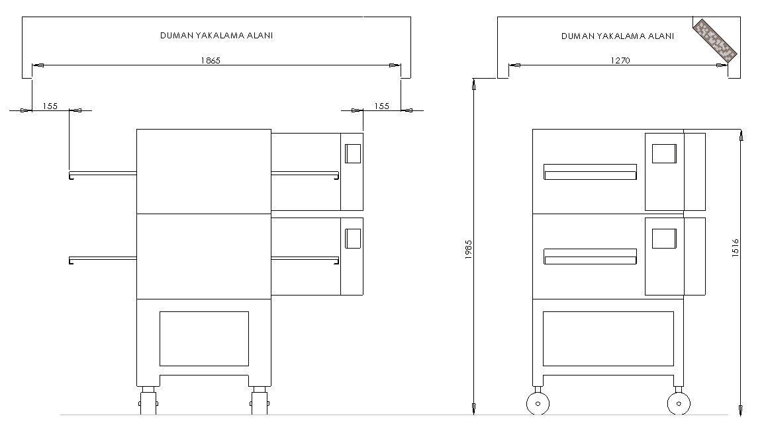
3.3 Ventilation Advice:
SMOKE CAPTURE AREA
1260
SMOKE CAPTURE AREA
1270

You are ready for services to be connected. This should be done by a qualified electrician, or installer of your choice.
DO NOT ATTEMPT TO OPERATE THE OVEN until connection of utility service and installation has been fully inspected (START-UP CHECKOUT) by and Authorized Service Technician.

This is important service, in order to assure the oven(s) is/are properly installed and in working order. The warranty becomes effective upon verification of proper installation. The warranty shall not apply if the oven(s) is/are started up and operated prior to the “START-UP CHECKOUT” being performed by an Authorized Service Technician.
DANGER! Do not work around conveyor belt with long hair, loose clothing, or dangling
jewelry. Getting caught in the belt could result in serious injury.
DANGER! If the power supply cord appears to be damaged, do not attempt to operate
the unit. Contact a service agent or qualified electrician to repair!

3.4 Installation Elements:
3 x 16 A (K AUTOMAT) – Fuse
Cable section: 1, 5 mm² (TTR Cable – 3 Faze / 1 Neutral / 1 Ground)
NOTE: (TTR cable is flexible so you could move oven. But antrigon cable harder than TTR cable. Our company offers you TTR cable. (But you can use Antrigon cable.) (1,5mm²) Also you can pull earthing from outside.
Grounding has to be proper.
Use regulator if voltage is high or low.
NOTE: If you fallow the above steps, assembly process can be made smoothly and quickly.

3.5 SEN 1100 Oven Technical Specifications Table:
Oven Electricity Technical Specifications Table
Voltage | Faze | N | T (PE) | Cable Minimum Section | kW | Ampere Load
 |  |  |  |  |  | L1 | L2 | L3
400 V 50/60 Hz | 3 | 1 | 1 | 1,5 mm² | 6 kw | 9 | 9 | 10,5

SEN 1100 3 FAZE CONNECTION
1

R

2
S

3
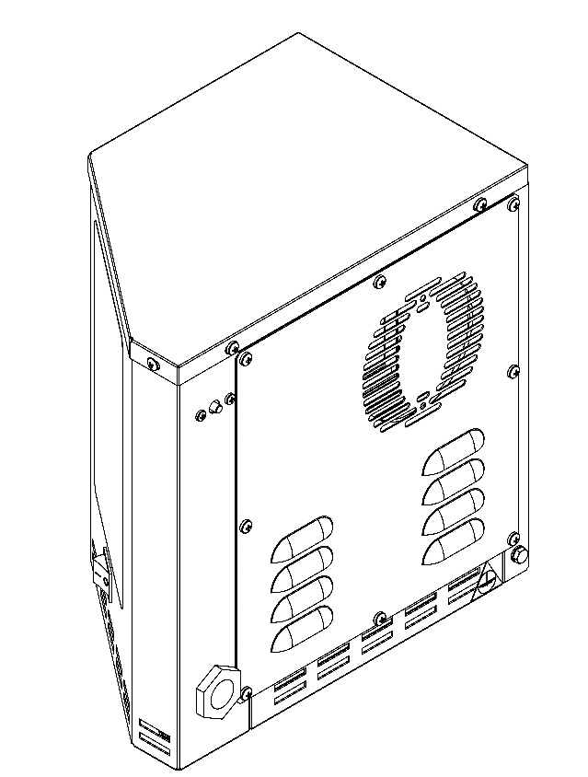
T

R
1
2
3
4
5
S
T
Terminal
Blog
N
PE
POTENTIAL GROUNDING
CIRCUIT BREAKER
POWER CABLE ENTRANCE

SECTION 4: PROGRAMING - START & STOP
All functions of the oven are controlled by the microprocessor. The oven must be pre-programmed for operation. The following pages are described step by in programming.
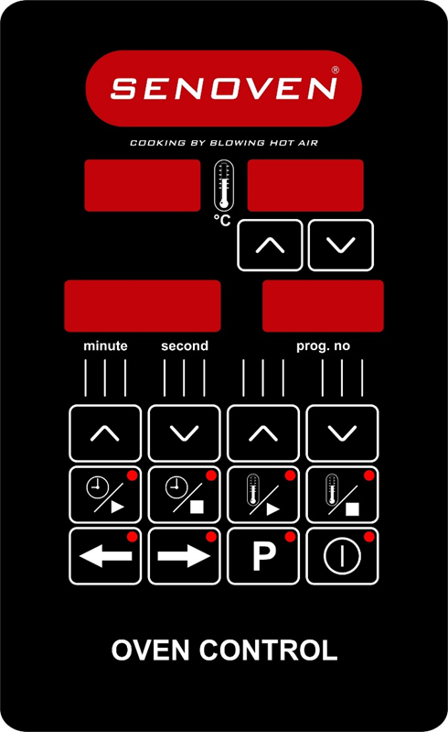
OVEN CONTROL DEVICE

Working Condition

Working Temperature: -20 - 70°C
Maximum Damp: %90 Rh (without condensation)
Height: Up to 2000 meters
Environments where device use is not suitable.
Corrosive atmospheric environments.
Explosive atmospheric environments.
Home applications. (The device only can be used industrial applications).

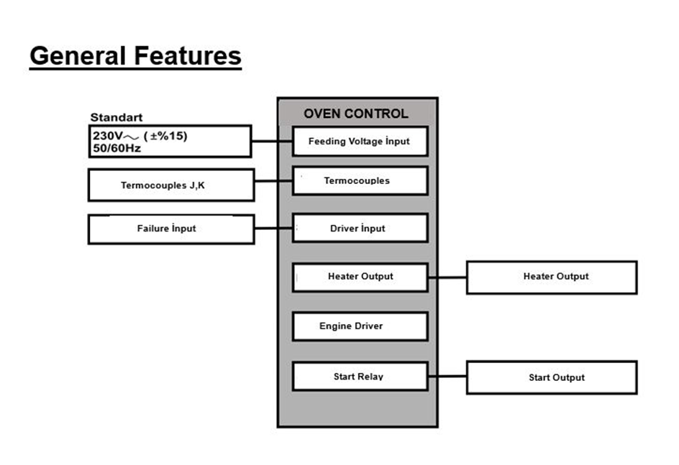
General Features
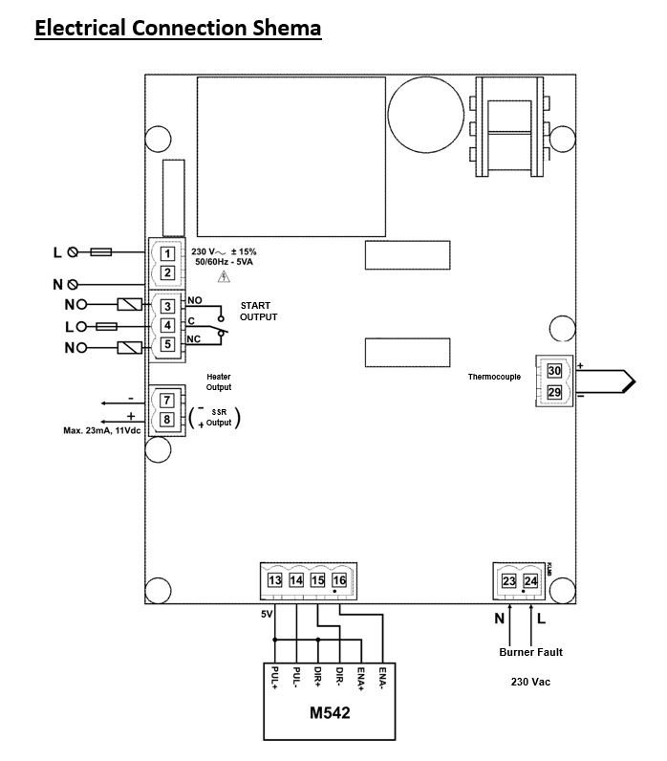
Electrical Connection Shema

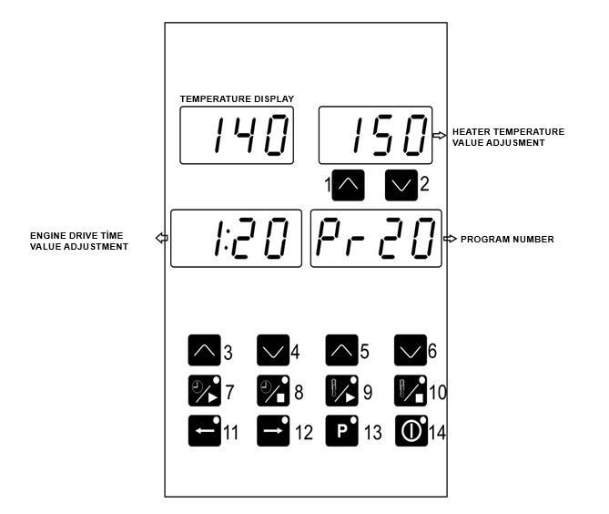
Oven Control Device Front Panel Definition

1 - 2. Temperature Set Increase and Decrease Buttons: With these buttons, the temperature set valves of program number that appear on the upper display are changed.
3 - 4. Engine Driver Time Increase and Decrease Buttons: Set the time in minutes and seconds with these buttons.
5 - 6. Program Increase and Decrease Buttons: The desired program number is selected using these buttons.
7. Engine Start Button: Press this button to start the engine.
8. Engine Stop Button: Press this button to stop the engine.
9. Heater Start Button: Press this button to activate the heater output is active.
10. Heater Stop Button: This button stops the output when heater output is active.
11. Belt Back Button: Rotates the engine counterclockwise when this button is pressed.
12. Belt Forward Button: Rotates the engine clockwise when this button is pressed.
13. Program Set Button: Press this button once for 5 seconds and enter the set section.
14. ON/OFF Button: With this button the device is returned to the “on’’ or “off ’’ state . Button turns off when the device is switched off screen turns off.

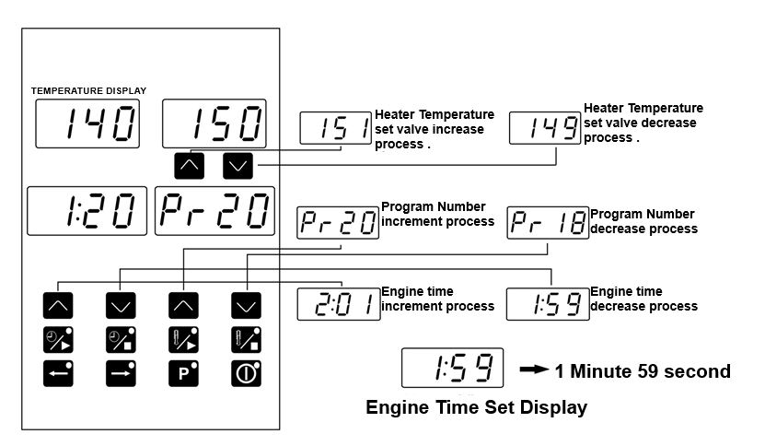
Changing Program Values and Record

The values of that program appear on the screens after the program number has been entered. Set values are changed with the help of boost and decrease buttons. Press ‘P’ button for 5 seconds to enter the set section. In this case the changed set values are recorded. The set values that are modified are instantaneous values. These values are not saved to the program. The old values of the program are displayed again when switching to the off position or when the power is turned off.

Programs are only saved when the heater is in the stop position. The set values changed in the start position are instantaneous values. These values are not saved to the program. The old values of the program are displayed again when switching to the stop position.
4.1 Operating:
With the start – stop switch (4) the machine is energized. Heat (2) and band rate (1) are adjusted according to the product to be cooked. The product is these cooked with the help of them.
4.2 Warnings:
1. If product not cooking, check cooking times and heat set.
2. If the product over cooked, check cooking times and heat set. Conveyor can be slowly.
3. If all values are normal but the product still doesn’t cook or over heat, call the manufacturer.
4.3 Closing:
Top the switch off the oven. The attention, you can turn off the switch on the display will appear. And then you can turn off switch.

4.4 Function:
4.4.1 Temperature Cutting Switch:
Our oven has a temperature cut. Off switch for you safety and protection. This switch is specially designed to prevent the oven from overheating and causing damage in a small possibility, if the operating temperature of the furnace increases and the power is prevented from being transferred to the furnace. No parts are damaged due to excessive temperature.

WARNING! Do not use an external switch to do not block to the temperature switch.

4.4.2 Band Right Left Function:
The direction of the tape can change direction according to the way of production. Therefore band left right key is available.
4.4.3 Electrical Installations:
WARNING! Grounding must be done properly before install of the oven. Electrical damage causes fatal injuries or death.

When the installation is done, the product must be fully grounded.
All Other Countries: Local electricity laws take precedence.
All Pole connection cutting buttons have 3 mm contact opening.
4.4.4 Operator Maintenance:
WARNING! Disconnect power supply before servicing or cleaning this oven Safeguard power so it cannot be accidentally restored. Failure to do so could result in dismemberment, electrocution, or fatal injury. There is more than one power supply connection point when ovens are stacked. Make sure that all switches are in the “OFF” position before cleaning or maintenance.
To maintain maximum efficiency of the oven, it is necessary to keep it clean, all ventilation louvers on the oven must be cleaned regularly. Oven use and type of product will actually determine the frequency of cleaning. The conveyor drive chain should be checked during the weekly cleaning cycle to see if it has become loose. Loose chain operation will DAMAGE the conveyor drive motor.
If the oven fails to operate, check the circuit breaker to be sure it is turned on. Be sure that circuit breaker is ok before you call the Authorized Service Agency. The name and phone number of the Authorized Service Agency should be located at the bottom of the data plate.

4.4.5 Cleaning Instructions:
The oven contains electrical components. Before cleaning the oven, switch off and disconnect the oven from the electrical supply.
No electrical components should be subjected to moisture. It is, therefore, important that the oven is wiped down carefully. NEVER throw buckets of water over the oven or subject it to pressure washing from a hose or a pressure spray. If water or other liquid is spilled on the oven, make sure that none has entered the control box area before switching on. If in doubt, call your service company.

WARNING! Oven must be cool. Do not use power-cleaning equipment, steel wool, or wire brushes on stainless steel surfaces.

DAILY;
- Clean the outer surfaces with a mild detergent cloth. You can also use a commercial stainless-steel cleaner product. Then clean the detergent residue with a wet cloth.
- Wash the preservatives of the front and rear waste collection plates with a mild detergent and rinse with water.
- Wash the outlet sheet with a mild detergent and rinse with water.
- Wash the stoppers with a mild detergent and rinse with water.
- Clean the loose particles inside, then wipe them with a mild detergent, and clean the detergent residue with a wet cloth.
- Clean the conveyor with a clean cloth or with a soft wire brush.

On exterior of oven, deposits of baked-on splatter, oil, grease, or light discoloration may be removed with any of several commercial cleaners. Consult with your local supplier.

MONTHLY;
- Remove, disassemble and clean air vents. Refer to "Air Duct Removal” for more information.
- Remove the tape, dismantle and clean it. See “tape mounting and wire mounting” for more information.
- Remove, disassemble and clean the oven room front and rear covers.

NOTE: Be sure to clean and inspect the ventilation hood in accordance with the ventilation hood manufacturer’s specifications.

4.4.6 Protective Maintenance:
Although this oven has been designed to be as trouble free as possible, periodic Preventive Maintenance is essential to maintain peak performance. It is necessary to keep the motors, fans, and electronic controls free of dirt, dust and debris to insure proper cooling. Overheating is detrimental to the life of all components mentioned.
The periodic intervals for preventative cleaning may vary greatly depending upon the environment in which the oven is operating.
You must discuss the need for Preventive Maintenance with your Authorized Service Company to establish a proper program.

4.4.7 Contact with Technical Services:
If the oven fails to operate, check the circuit breaker to be sure it is turned on. In addition, be sure that the circuit breaker is good before you call the Authorized Service Agency. The name and phone number of the Authorized Service Agency should be located on the oven or contact the factory for the name of the nearest Authorized Service Agency.

SECTION 5: COOKED PRODUCTS
5.1 Some of The Cooked Products:
- Brownie
- Hamburger
- Hot Dogs
- Omelet
- Pancakes
- Mixed Vegetable Plate
- Steakhouse
- Skewers
- Meatball
- Potato
- Borek
- Chicken Wings
- Grilled Chicken

- Chicken Saute
- Bread
- Breakfast
- Fish
- Seafood
- Pizza
- Lavas
- Lahmacun
- Pita
- Kunefe
- Chocolate Cookie
- Pie
- Etc. Many Foods

SEN 1100 series ovens, show much better performance than other ovens (Especially pizza cooking).

5.2 Cooking Time and Temperature:

PİZZA
- 260 °C
- TIME: 6 MINUTES
- ALUMINIUM PAN
- FRESH

PİDE
- 260 °C
- TIME: 5 MINUTES
- OVER CONVEYOR
- FRESH

5.3 Total Cooking Calculation:

Pan Length
(A)
Sample 1:
Oven Chamber Length: 530 mm.
Cooking Time: 2 dk.
Pan Length: 250 mm.

250
1
2
3
2
1

Sample 2:
Oven Chamber Length: 530 mm.
Cooking Time: 5 dk.
Pan Length: 500 mm.

500

Pan Length
(B)

5.4 Sample Capacity Table:

SAMPLE CAPACITY TABLE
Dimeter Pizza | 3 Minutes | 3 ½ | 4 Minutes | 4 ½
30 cm | 36 | 31 | 27 | 24
36 cm | 28 | 24 | 21 | 19
41 cm | 26 | 22 | 20 | 17
Dimeter Pizza | 5 Minutes | 5 ½ | 6 Minutes | 6 ½
30 cm | 22 | 20 | 18 | 17
36 cm | 17 | 15 | 14 | 13
41 cm | 16 | 14 | 13 | 12
Dimeter Pizza | 7 Minutes | 7 ½ | 8 Minutes
30 cm | 15 | 14 | 13
36 cm | 12 | 11 | 10
41 cm | 11 | 10 | 10

SECTION 6: SPARE PARTS MANUAL

SPARE
PARTS
MANUAL

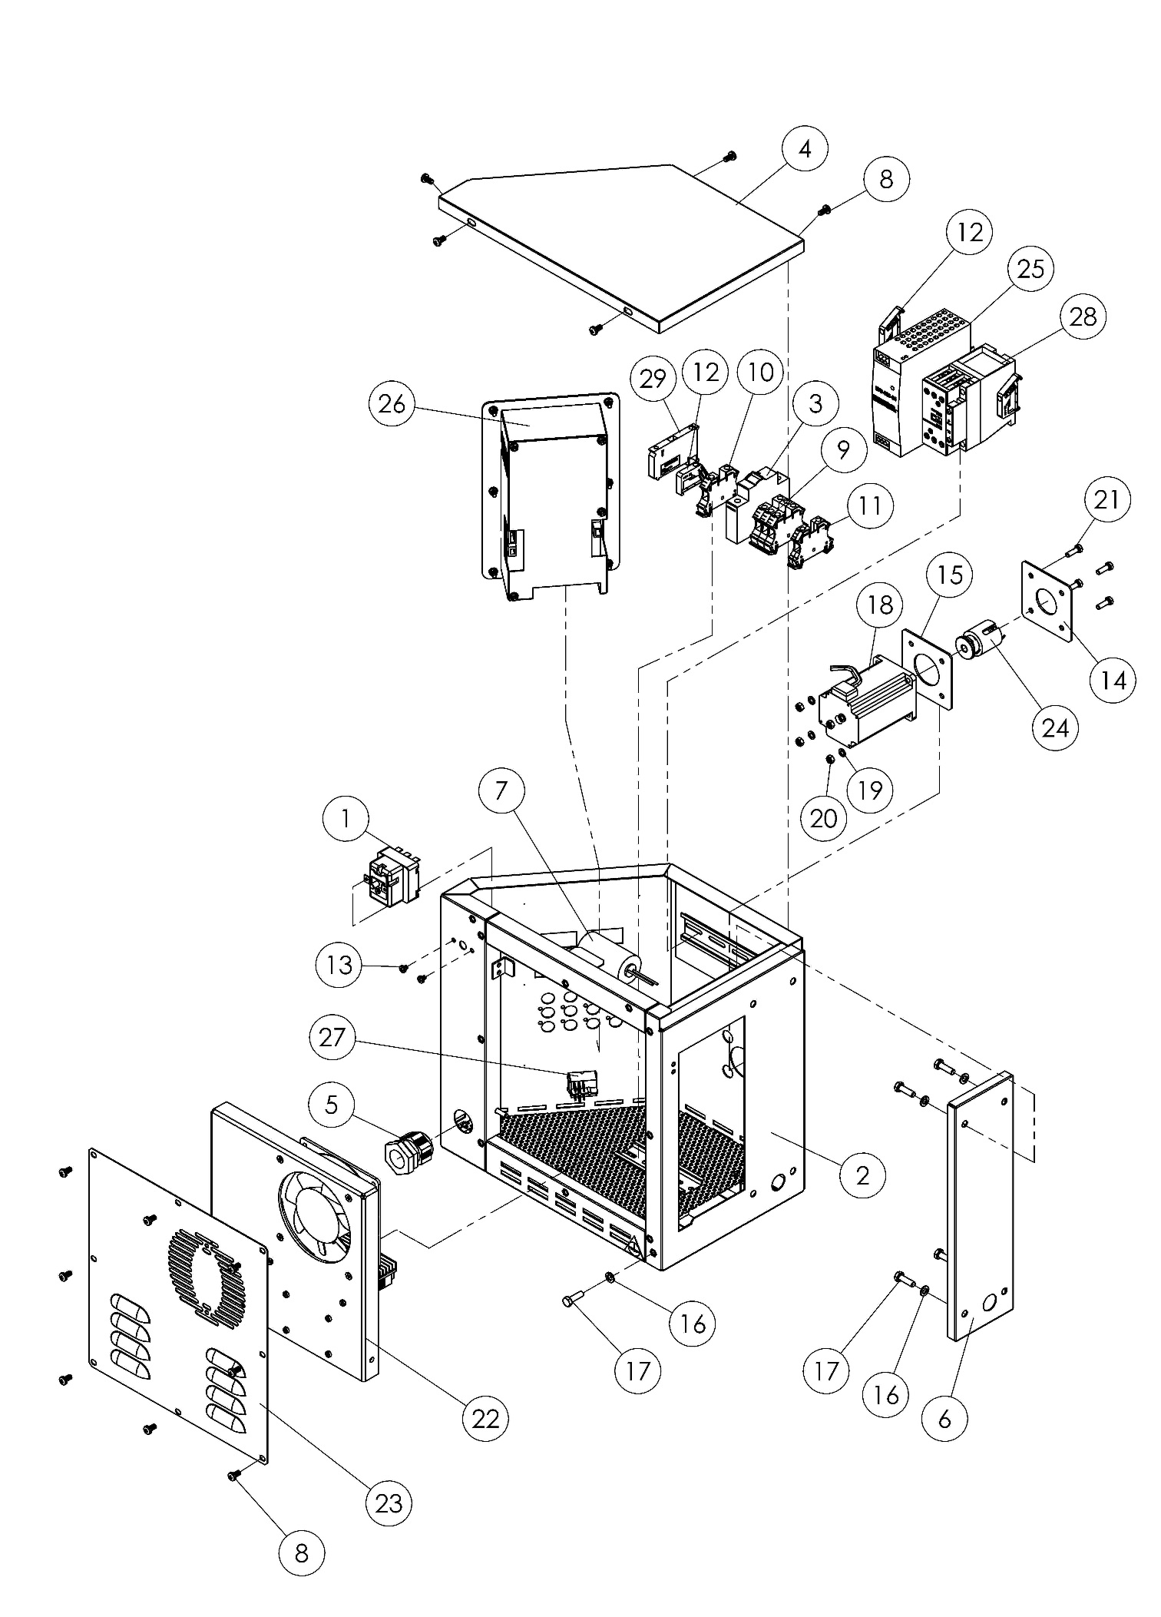
M00368
FRONT

M00368 FRONT SPARE PARTS LIST
ITEM NO. | SPARE PART NUMBER | SPARE PART DESCRIPTION | UNIT
1 | 01815 | LIMIT THERMOSTAT | 1
2 | 00303M | BODY | 1
3 | 02189 | FUSE | 1
4 | 01894 | CONTROL BOX COVER | 1
5 | 08054 | RECORD | 1
6 | 02279 | SUPPORT SHEET | 1
7 | 02194 | CONDENSER | 1
8 | 00046 | BOLT | 13
9 | 02211 | TERMINAL BEIGE | 3
10 | 02210 | TERMINAL BLUE | 1
11 | 02209 | TERMINAL | 1
12 | 00292 | LIMITER | 3
13 | 01831 | BOLT | 2
14 | 02281 | ENGINE SHEET | 1
15 | 02280 | ENGINE SHEET | 1
16 | 00042 | WASHER | 5
17 | 00041 | BOLT | 5
18 | 02317 | ENGINE | 1
19 | 01685 | RONDELA | 4
20 | 00052 | NUT | 4
21 | 00049 | BOLT | 4
22 | 00304M | SSR BOX | 1
23 | 01896 | BACK COVER | 1
24 | 00172M | BODY | 1
25 | 02319 | POWER SOURCE | 1
26 | 00316M | SCREEN | 1
27 | 08091 | BUTTON | 1
28 | 01615 | KONTAKTOR | 1
29 | 01865 | GLASS BRAKER TERMINALS | 1

PROFILE- 1

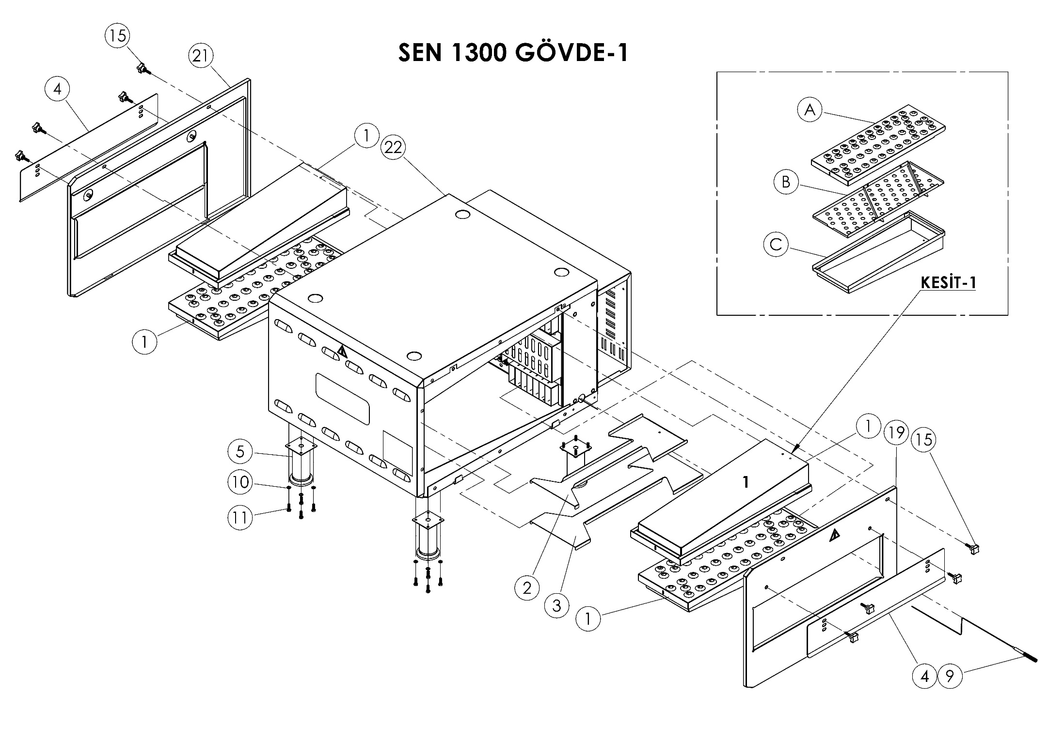

SEN 1100 BODY -1

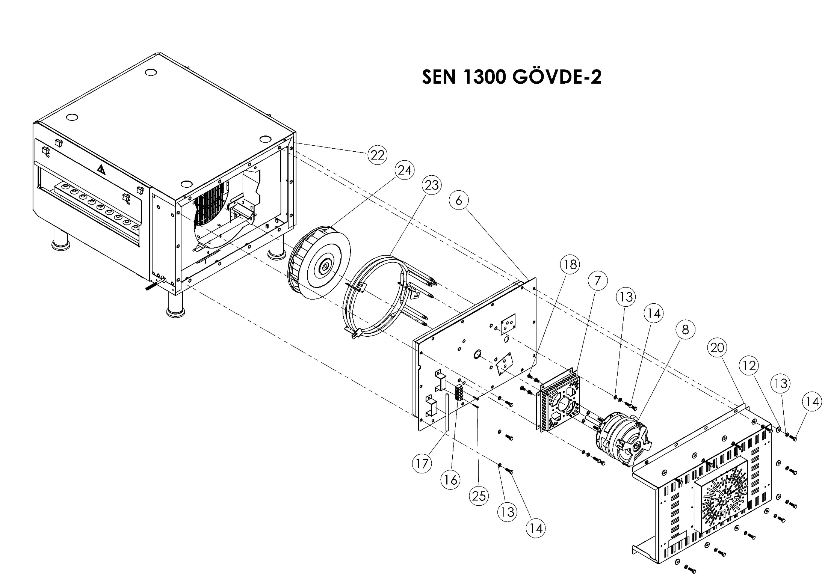

SEN 1100 BODY -2

SEN 1100 BODY 1-2 SPARE PARTS LIST
ITEM NO. | SPARE PART NUMBER | SPARE PART DESCRIPTION | UNIT
1 | 00176M | AIR DUCT SHEET | 4
2 | 02225 | AIR DUCT SUPPORT SHEET | 1
3 | 02227 | AIR DUCT SUPPORT SHEET | 1
4 | 02226 | ENTRY AND EXIT COVER SHEET | 2
5 | 08086 | LEG | 4
6 | 00179M | BACK ISOLATED COVER | 1
7 | 02266 | FAN ENGINE SHEET | 1
8 | 02325 | ENGINE | 1
9 | 01731 | THERMOCOUPLES | 1
10 | 01685 | WASHER | 16
11 | 01833 | BOLT | 16
12 | 01299 | WASHER | 11
13 | 00042 | WASHER | 22
14 | 00041 | BOLT | 22
15 | 01596 | BAKELITE | 8
16 | 01728 | TERMINAL | 1
17 | 01317 | REZISTANCE OUTPUT TERMINAL | 1
18 | 02580 | BOLT | 4
19 | 00181M | SIDE COVER | 1
20 | 00180M | BACK COVER | 1
21 | 00184M | SIDE COVER | 1
22 | 00187M | BODY | 1
23 | 02328 | REZISTANCE | 1
24 | 02311 | FAN | 1
25 | 01672 | BOLT | 14
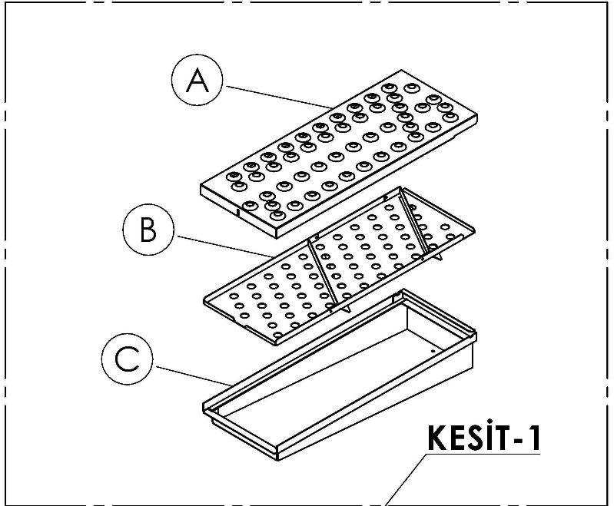
00176M (PROFILE-1) SPARE PARTS LIST
ITEM NO. | SPARE PART NUMBER | SPARE PART DESCRIPTION | UNIT
A | 02236 | AIR DUCT TOP SHEET | 1
B | 00192M | AIR DUCT SHEET | 1
C | 00193M | AIR DUCT PADDLE BOX SHEET | 1

PROFILE- 1

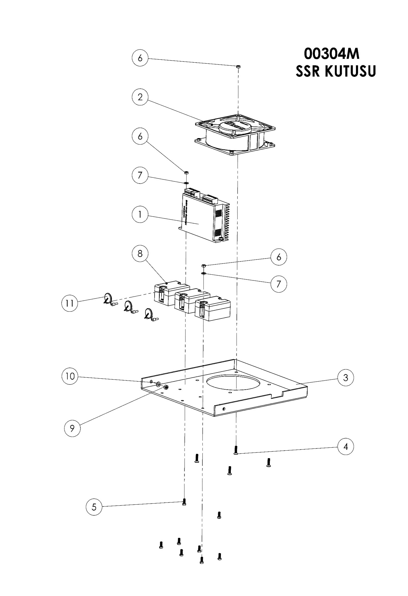
00304M SSR BOX

00304M SSR BOX SPARE PARTS LIST
ITEM NO. | SPARE PART NUMBER | SPARE PART DESCRIPTION | UNIT
1 | 02320 | SPEED CONTROL UNIT | 1
2 | 01290 | FAN | 1
3 | 01903 | SSR SHEET | 1
4 | 01319 | CİVATA | 4
5 | 01295 | CİVATA | 8
6 | 02634 | NUT | 12
7 | 01296 | PUL | 8
8 | 01822 | SSR RELAY | 3
9 | 00052 | NUT | 2
10 | 02582 | WASHER | 2
11 | 01292 | VARISTOR | 3

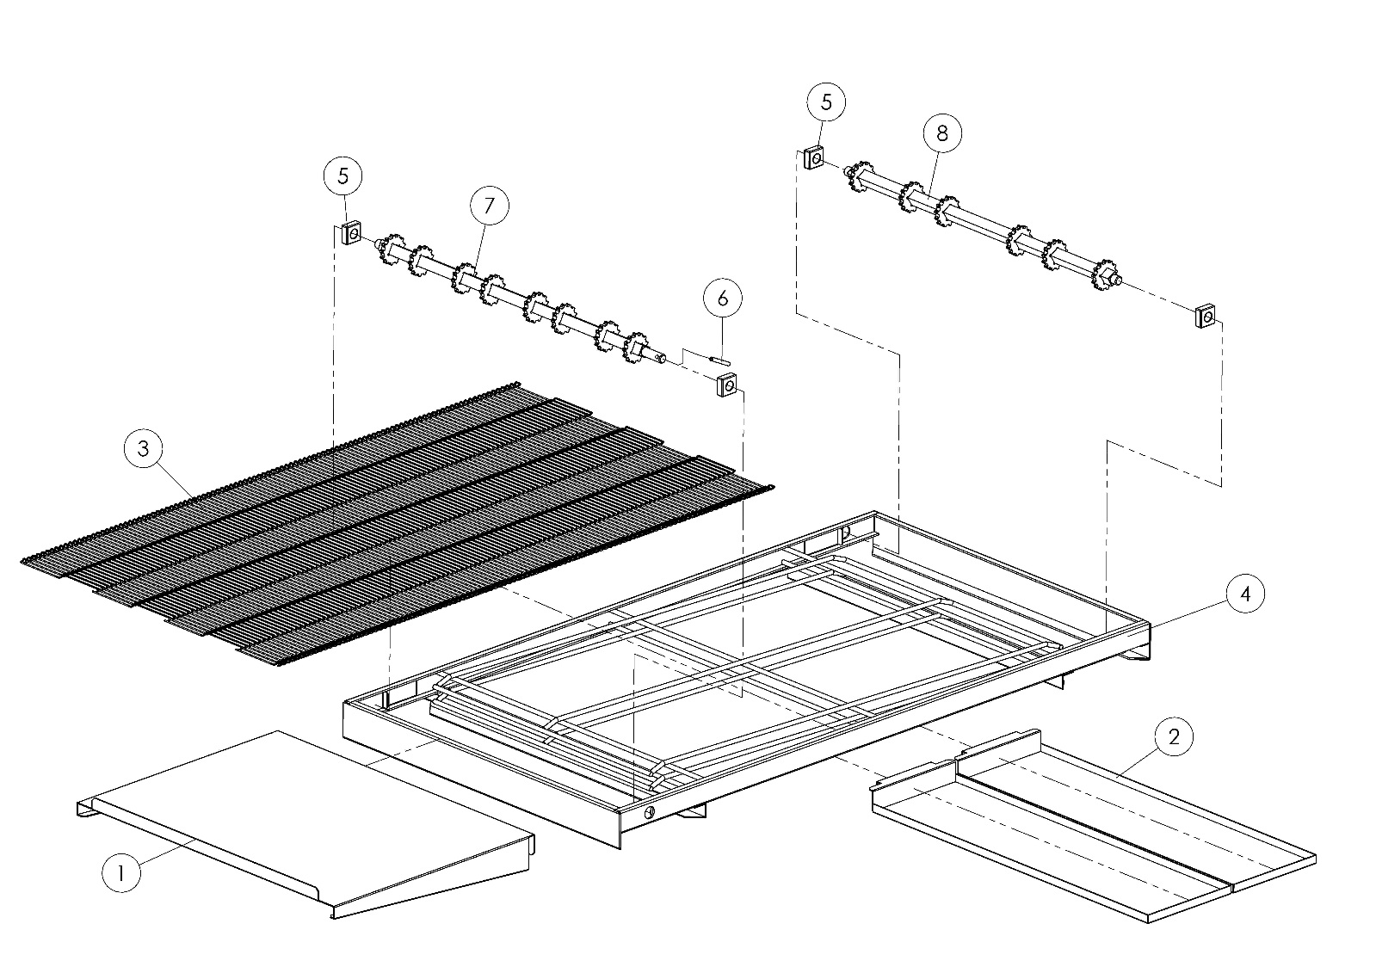
M00410 BELT

M00410 BELT SPARE PARTS LIST
ITEM NO. | SPARE PART NUMBER | SPARE PART DESCRIPTION | UNIT
1 | 02295 | PRODUCT OUT SHEET (OPTIONAL) | 1
2 | 02294 | WASTE PAN | 2
3 | 01189M | BELT | 1
4 | 00379M | BELT CHASIS | 1
5 | 01516 | CONVEYOR DRIVE BEARING | 4
6 | 00096 | PIN | 1
7 | 00428M | CONVEYOR DRIVE SHAFT | 1
8 | 00429M | CONVEYOR IDLE SHAFT | 1

SECTION 7: ELECTRICAL DIAGRAM SECTION

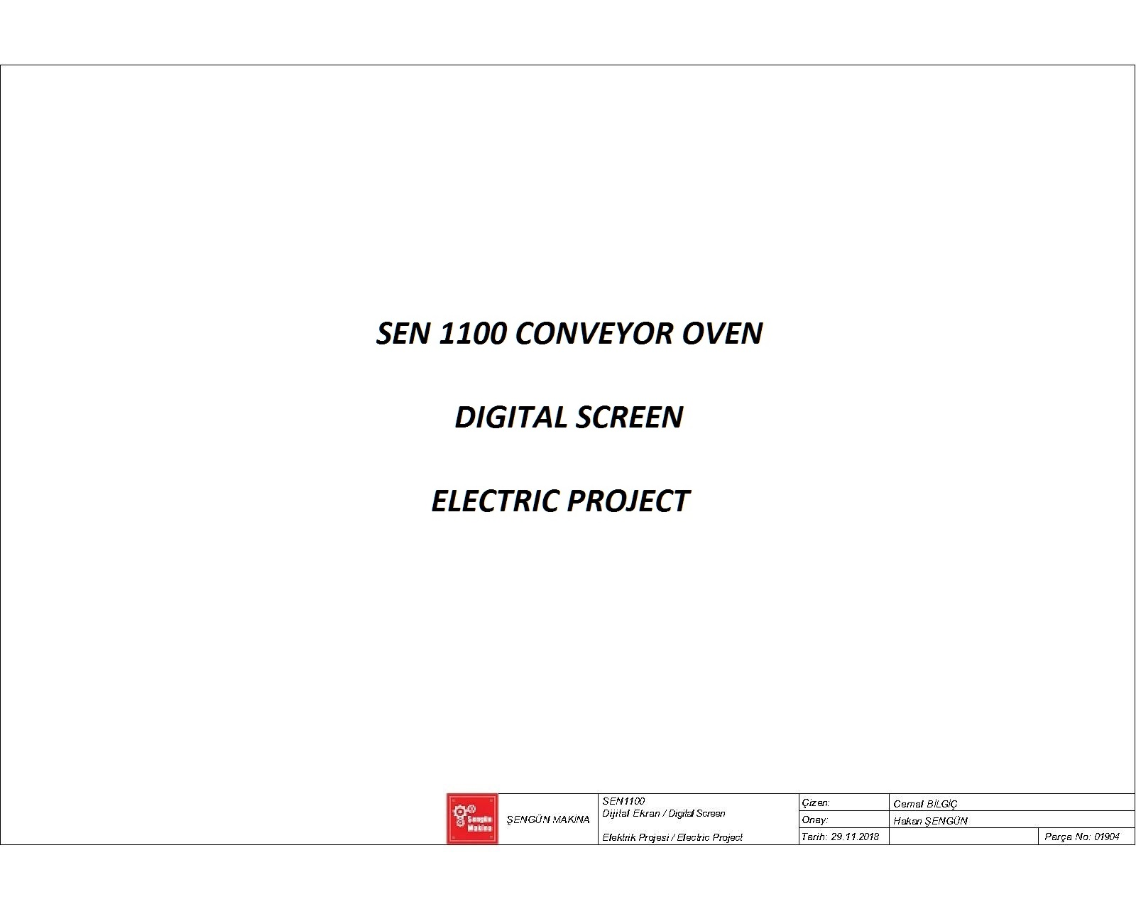

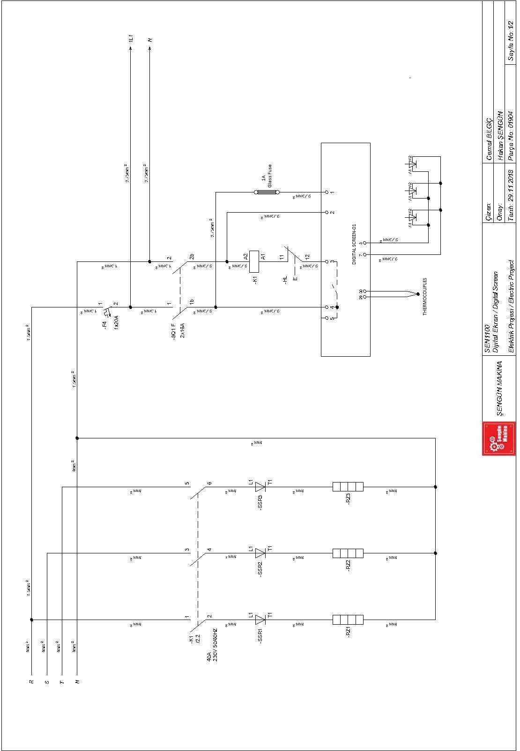

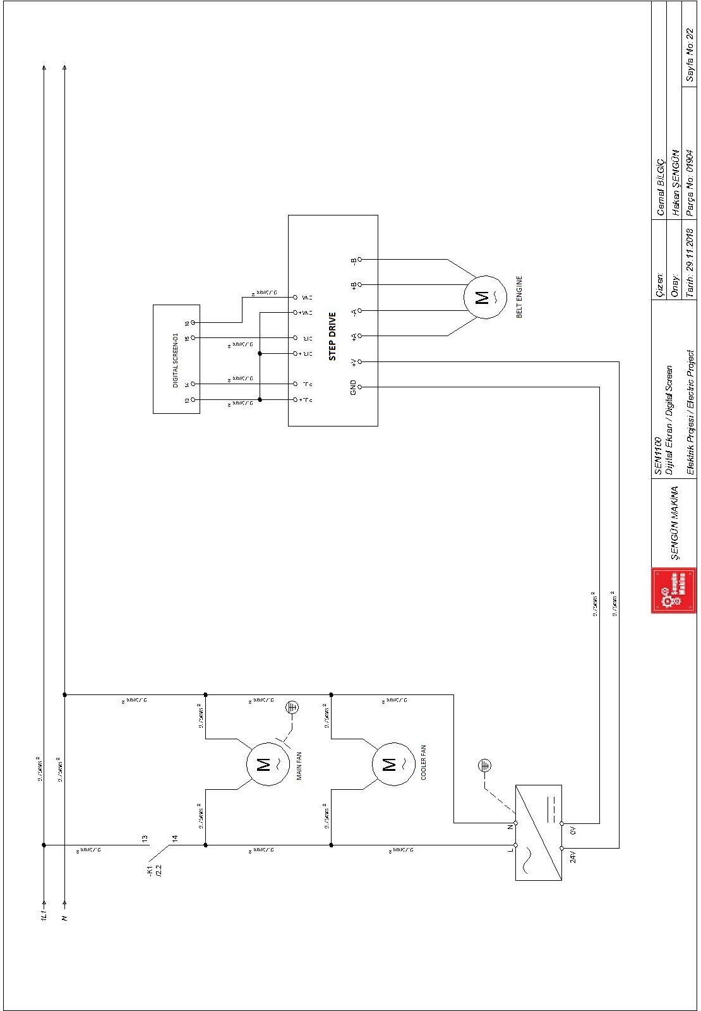

SECTION 8: LABELS



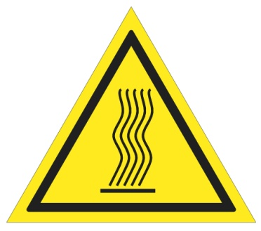
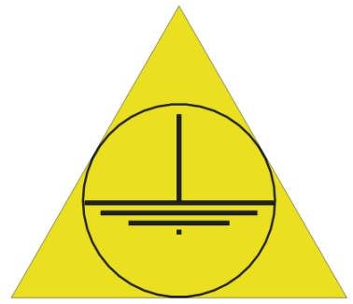

(High Temperature) (Grounding)

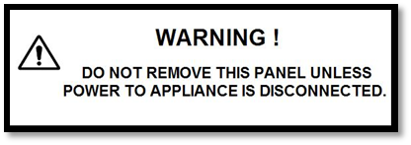

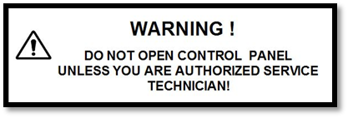

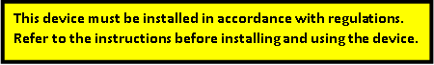
Electrical Input

Warning Labels

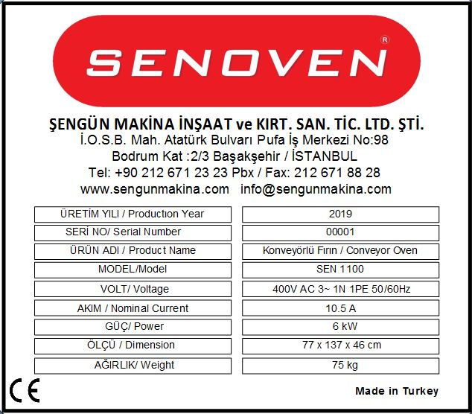

Technical Label (Product Card)

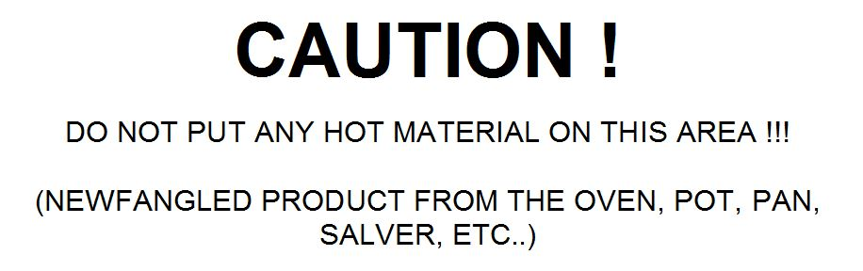

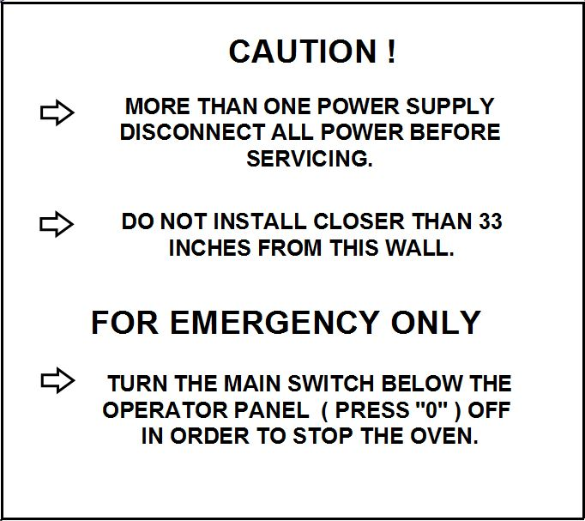

Warning Label

NOTE:

ŞENGÜN MAKİNA İNŞAAT VE KIRTASİYE SAN. TİC. LTD. ŞTİ.
İkitelli Organize Sanayi Bölgesi, Atatürk Bulvarı, Pufa İş Merkezi No: 98 Bodrum Kat: 2-3
Başakşehir/ İstanbul/ Türkiye

Phone: +90 212 671 23 23 (Pbx)
Phone 2: +90 212 671 84 84
Fax: +90 212 671 88 28
GSM: +90 533 957 14 53

e-Mail : info@sengunmakina.com
web : www.sengunmakina.com



